

Table of Contents
Chapter 1 5
Introduction to Retirement Funds 5
1.1 Retirement Funds defined 6
1.2 Registration of Retirement Funds 6
1.3 Cancellation or suspension of registration of Retirement Funds 7
1.4 Rules of a retirement fund 8
1.5 Protection of Retirement Benefits 8
1.6 Types of Retirement Funds 10
1.7 The difference between a Pension and a Provident fund 15
1.8 Retirement fund designs 15
Chapter 2 19
Legislation of Retirement Funds 19
2.1 Key Sections of the Pension Funds Act, 1956 (Act No. 24 of 1956) 20
2.2 Default Regulations Summarized 22
2.3 Taxation of Retirement Funds 26
Chapter 3 30
Financing of Retirement Funds 30
3.1 Financing of Retirement Funds 31
3.2 Basic types of Retirement Funds 32
3.3 Fund Costs and pricing methods 34
Funds operating costs 34
Fund administration costs 34
Fund Investment costs 34
Asset Manager fees, Investment consulting and bank charges 34
Risk Benefits costs 34
Chapter 4 36
Management of Retirement Funds 36
4.1 Management Board (Section 7A of the Pension Fund Act 1956) 37
4.2 Duties of the management board (Section 7D of the Act) 38
Principle 1 – Retirement funds are separate legal entities. 40
Principle 2 – Trustees make decisions 40
Principle 3 – The Fund rules are king 40
Principle 4 – Membership to the fund is compulsory for all eligible employees 40
Principle 5 – Funds are designed with the sole purpose of providing retirement benefits and/or risk benefits. 40
4.3 Who may act (Selection and appointment of Trustees)? 40
4.4 Managing Conflict of interest in Retirement Funds 41
4.5 Trustee liabilities and protection 42
4.6 PF Directive 8 - Prohibition on the Acceptance of Gratification 43
4.7 Trustee qualifications and experience 45
4.8 Trustee decision making 47
4.9 Delegation of Trustee powers and duties 47
4.10 Conducting Trustee meetings 48
4.11 Removal / Suspension of Trustees 49
Chapter 5 50
Investing Retirement Fund Assets 50
5.1 The Trustee's duty to invest fund assets 51
5.2 Investment Portfolio 51
5.3 Regulation 28 – Guidelines on Retirement fund Investments 54
5.4 Portfolio Management Styles 54
Active Portfolio Management 54
Passive Portfolio Management 55
5.5 Key Investment Fundamentals for Retirement funds 56
5.6 Investment Policy Statement 59
5.7 Statement of Investment Policy Principles (“SIPP”) 60
5.8 Investment Portfolio Structures 61
5.9 Investment Vehicles available to Retirement Funds 62
5.10 Investment approaches used by Funds 63
5.11 Fund Investment Designs 64
5.12 Appointing an investment manager 67
5.13 Monitoring fund investment performance 69
5.14 How do you measure investment performance? 69
5.15 How do you measure risk? 71
5.16 Investment management agreement 71
5.17 Investment Manager Termination 71
5.18 Socially Responsible Investing 72
5.19 The Impact of recent economic developments on investments 77
Chapter 6 78
Retirement Fund Benefits 78
6.1 Retirement Benefits 79
6.2 Risk Benefits 87
6.3 Death Benefits 89
6.4 Withdrawal Benefits 95
6.5 Disability Benefits 95
6.6 Group Funeral Benefits 97
6.7 Home Loans 97
Chapter 7 99
Fund Administration and Record-Keeping 99
7.1 Trustee Responsibilities 100
7.2 Types of fund administration 101
7.3 Payment of contributions due to a retirement fund 101
7.4 Record Keeping 102
7.5 Financial Statements 103
7.6 Member Communication 104
Chapter 8 107
Governance of Retirement Funds 107
8.1 What does Fund Governance entail? 108
8.2 Tools that Trustees use to enhance Governance 110
8.3 King IV Code – Aspects relevant to Retirement Fund Governance 111
8.4 Governance Principles that the board should observe are; 113
Chapter 9 114
Industry Role Players 114
9.1 The Member / Beneficiaries 115
9.2 The Board of Trustees 115
9.3 The Principal Officer (Section 8, Pension Funds Act). 116
9.4 Chairperson of the Board of Trustees 117
9.5 The Investment / Asset Manager 117
9.6 Investment Consultant 118
9.7 The Fund Valuator / Actuary (Section 9A of the Act) 118
9.8 The Fund Auditor 120
9.9 The Employer 121
9.10 The Fund Administrator 122
9.11 The Benefit Consultant 123
9.12 Life Assurance Company 123
9.13 The Financial Sector Conduct Authority (FSCA) and Prudential Authority (PA) 124
9.14 The Office of the Pension Funds Adjudicator 124
9.15 South African Revenue Service 125
9.16 South African Banks 125
Glossary of Pension Terms 126
References 133
Gloossary of terms Error: Reference source not found6
References Error: Reference source not found33

Chapter 1

Introduction to Retirement Funds
Good knowledge of this chapter will ensure competency in the following specific outcomes:
- Define retirement funds
- Explain registration requirements for retirement funds and the effect of registration
- Discuss the suspension and cancellation of fund registration
- Explain the importance of Rules on retirement funds
- Discuss how retirement fund benefits are protected from insolvency provisions
- Describe the different types of retirement funds
- Describe the different fund designs on the market
- Explain the difference between standalone and umbrella funds and advise a client accordingly.

1.1 Retirement Funds defined
Retirement funds are established with the sole purpose of providing those covered by the funds with an income to replace earnings in the event of their retirement, or perhaps early retirement through ill health. Such funds will often additionally provide benefits for surviving dependents in the event of the death or disability of the member.
Retirement Funds in South Africa are managed in terms of the Pension Funds Act, 1956.
The Act defines "pension funds" as follows.
- any association of persons established with the object of providing annuities or lump sum payments for members or former members of such association upon their reaching their retirement dates, or for the dependants of such members or former members upon the death of such members or former members; or
- any business carried on under a scheme or arrangement established with the object of providing annuities or lump sum payments for persons who belong or belonged to the class of persons for whose benefit that scheme or arrangement has been established, when they reach their retirement dates or for dependents of such persons upon the death of those persons; or
- any association of persons or business carried on under a scheme or arrangement established with the object of receiving, administering, investing and paying benefits that became payable in terms of the employment of a member on behalf of beneficiaries, payable on the death of more than one member of one or more pension funds,

1.2 Registration of Retirement Funds
Section 4 of the Pension Funds Act, 1956 provides for the registration of Pension Funds.
- Every pension fund must, before commencing any pension fund business—
(a) Apply to the registrar for registration under the Act, and
(b) Be provisionally or finally registered.
- Applications are processed and granted by the Registrar once all requirements have been met for the registration of the Fund and the prescribed fee paid.
Upon successful registration, the Registrar will provide the following.
- A registration certificate
- Details of the fund as entered in the fund's register
- Endorsed (approved) rules of the fund.
The Act provides for provisional registration for a period of up to 5 years.
Every retirement fund becomes a juristic person (body corporate) on the receipt by its Principal Officer of written confirmation of its registration by the Registrar, meaning it becomes capable of suing and being sued in its name and doing all the lawful things to exercise the powers vested in it to carry out the functions ascribed to it in terms of its rules and to carry out its duties in terms of the Act.

1.3 Cancellation or suspension of registration of Retirement Funds
Section 27 of the Act provides for the cancellation or suspension of registration of Funds under the following circumstances.
- The registrar shall cancel the registration of a fund
- on proof to his satisfaction that the fund has ceased to exist; or
- if the registrar and the fund are agreed that the fund was registered by mistake in circumstances not amounting to fraud, then the registrar may suspend the fund whilst allowing the fund to rectify any mistakes. If not rectified, the registrar will proceed to cancel the registration.
- The registrar may apply to the court for the cancellation or suspension of the registration of a fund if the fund has wilfully and after notice from the registrar violated any provision of the Act.
- The court may cancel the registration of the fund or suspend such registration for such period as it thinks fit and may attach to such cancellation or suspension such conditions as it thinks desirable or may make any other order which in the circumstances it thinks desirable.
- Unless the court otherwise orders, the costs of the suspension or cancellation are paid by the fund and shall be the first charge upon the assets of such a fund.

1.4 Rules of a retirement fund
Sections 11 and 12 of the Act prescribe that:
- The business of a retirement fund shall be governed by a set of rules which shall comply with the prescribed requirements in terms of the Regulations.
- No rules shall be of any force unless those rules have been approved and endorsed by the Registrar.
- Subject to the provisions of this Act, the rules of a retirement fund shall be binding on the fund and its members, employer and officers, and any person who has a claim on the fund.
- Every member of a retirement fund shall be entitled to request to inspect a copy of the rules of the fund. (Sec 35 of the Act)
- Notwithstanding the provisions above, if the rules of the retirement fund are found to conflict with the Act on any aspect, then the provisions of the Act shall apply.
Amendment of rules
- A retirement fund may alter or rescind or make any addition to its rules provided that no such alteration, rescission or addition shall affect the rights of any creditor of the fund other than as a member or shareholder.
- All proposed amendments shall be submitted to the Registrar for approval within 60 days of the board's resolution approving the amendment.
- Any amendment to the rules which affect the financial condition of the fund shall be accompanied by a valuator's certificate certifying that the amendment will not render the fund financially unsound.
- Once the registrar is satisfied that the amendment is not against the members' or employer's interest, and not inconsistent with this Act, he shall register the amendment, and he returns an endorsed copy of the amendment to the fund.
- The resolution of the board must clearly state the effective date of the amendment.
- A fund may at any time consolidate its rules which shall take effect from a date decided by the management board but usually after 10 amendments have been made to the original rules.

1.5 Protection of Retirement Benefits
The general rule – set out in terms of section 37A of the Pension Funds Act – is that no benefit of a member may be reduced, transferred, ceded, or pledged by a fund other than as provided for in the Act.
For the same reason, a member in debt may also not pledge, transfer, or cede their retirement benefit to satisfy that debt.
Section 37D of the Pension Funds Act does permit certain deductions from a member’s retirement fund benefit. These are:
- Amounts due in respect of housing loans, granted by the fund/employer or for which the fund/employer agreed to stand surety.
- Pension interests awarded to former spouses on divorce.
- Maintenance claims awarded against the member and the fund.
- Damages due to an employer caused by a member’s misconduct; Misconduct must include an element of dishonesty by the member – mere negligence by the member will not suffice. This is according to the decision of the High Court in Moodley v Scottburgh/Umzinto North Local Transitional Council 2000 (4) SA 524 (D).
Proof of the member’s liability to the employer must be provided to the fund in either.
- A written acknowledgement of liability by the member, as well as the amount due.
- It can also be in the form of a judgement obtained against the member by the employer.
It must be noted that a criminal judgement against the member is not an order for compensation to be paid to the employer by the member. The employer should join the criminal case and apply for a compensation order, in terms of section 300 of the Criminal Procedure Act, for its claim to be satisfied by the fund.
- Amounts specifically approved by the Registrar.

1.6 Types of Retirement Funds
1.6.1 Pension Fund
Under a Pension Fund, a maximum of one-third of the fund benefit may be taken as a lump sum, in cash upon a member’s retirement. The balance two-thirds of the benefit will be paid as a pension for the rest of the pensioner’s life subject to the statutory minimum. Amounts below the set minimum can be taken as a cash lump sum.
1.6.2 Provident Fund
Under a Provident Fund, at retirement, the full fund credit may be taken as a lump sum. Members have the option to purchase an annuity from their lump sum if they so wish.
1.6.3 Preservation Fund
A Preservation Fund is a pension or provident fund to which a fund member can have his or her withdrawal benefits transferred after exiting their employment.
The fund preserves the member’s accrued benefits tax-free until the member reaches retirement age. The amount invested will continue to earn interest whilst in this fund. Usually, no additional contributions are allowed.
From 1 March 2019, a member will be entitled to transfer his post-retirement benefit to a preservation fund. The member will not be entitled to the one pre-retirement withdrawal option that is available to a member who transferred his withdrawal benefit to the preservation fund.
Withdrawal from preservation fund upon emigration or repatriation on expiry of a work or visitor visa: A member of a preservation fund will be entitled to withdraw his full lump sum benefit from that fund when he emigrates from South Africa and the emigration is recognised by the South African Reserve Bank for exchange control, similar to a member of a retirement annuity fund, even if the member has already made one pre-retirement withdrawal.
The Income Tax Act allows a pension preservation fund to accept divorce order payments from a pension fund, pension preservation fund, provident fund and a provident preservation fund.
1.6.4 Retirement Annuity Fund
A Retirement Annuity Fund is an arrangement set up by an administrator (mostly Life Assurance Companies) for individual members to save for their retirement. The tax laws allow for retirement from as early as age 55 for this purpose.
RAs are also beneficial in estate planning because they are excluded from your estate for estate duty calculation purposes. Once you reach retirement age you have the option of buying a life or living annuity to provide you with a monthly income in retirement. Furthermore, the value of the life or living annuity is excluded for estate duty purposes.
The only downside of an RA is that you cannot access your savings in your RA fund before the age of 55 unless you are officially emigrating, and then you will pay tax on the withdrawal.
1.6.5 Beneficiary Funds
A beneficiary fund is designed to accept and administer lump sum death benefits allocated to minor dependents by Trustees of deceased Fund members, as set out in section 37C(2)(a)(iii) of the Act.
Beneficiary funds are cost-effective, tax-effective (payments out of a beneficiary fund, whether capital or income, is tax-free), are governed by professional Trustees, and offer institutional investment returns. However, lump sum payments to a beneficiary fund are subject to tax under the 2nd schedule of the Income Tax Act 1962. The calculation for the amount of tax, if any, will take into account on any previous lump sums taken by a deceased member during his lifetime.
Beneficiary funds comply with the same regulatory and governance standards as any other retirement fund such as member communication policy, investment policy, code of conduct, and risk policy.
Upon the death of a Member, the Board has three duties.
- The first duty is to conduct a thorough investigation to identify the circle of potential beneficiaries, i.e. dependants and nominees.
- The second duty is to decide on an equitable distribution of the benefits.
- The third duty is to effect an appropriate mode of payment of the benefit.

Beneficiary funds play an important social role as a mode of payment for Trustees to consider, particularly among blue-collar worker families where guardians may not be sufficiently financially knowledgeable to manage minors’ funds on their own or where minor children are not staying with biological parents and their interests may not be sufficiently protected.

The Board must note that the payment of the minor child's benefit to her/his legal guardian should be done in the ordinary course of events unless there are valid reasons for depriving the guardian of the duty to take charge of her/his minor child's financial affairs.

The Board must consider the following relevant factors in making this decision:

(a) the amount of the benefit;
(b) the ability of the guardian to administer the amounts of money;
(c) the qualification (or lack thereof) of the guardian to administer the amounts of money;
(d) the time frame until the minor attains the age of majority;
(e) the nature of the relationship between the guardian and the minor child.
(f) the best interests of the minor child

The following reasons are sufficient to deprive the guardian or caregiver of the right to administer death benefits on behalf of a minor beneficiary: insolvency, mental disability, or incapacity to manage his affairs.
1.6.6 Unclaimed Benefit Fund
This means a fund that is established for the receipt of unclaimed benefits.
"Unclaimed benefit"
- any benefit not paid by a fund to a member, former member or beneficiary within 24 months of the date on which in terms of the rules of the fund, became legally due and payable;
- a death benefit payable to a beneficiary under section 37C not paid within 24 months from the date on which the fund became aware of the death of the member, or such longer period as may be reasonably justified by the board of the fund in writing.
- concerning a benefit payable as a pension or annuity, any benefit which has not been paid by a fund to a member, former member or beneficiary within 24 months of —
  - the expiry date of any guarantee period for pension payments provided for in the rules of the fund; or
  - the date on which any pension payment or annuity legally due and payable in terms of the rules of the fund became unpaid.
- a benefit payable to a former member who cannot be traced in accordance with section 15B(5)(e), and which has become legally due and payable to a former member in terms of a surplus apportionment scheme approved in terms of this Act not paid to that former member within 24 months of the date on which it became legally due and payable.

- any benefit that remained unclaimed or unpaid to a member, former member or beneficiary when a fund applies for the cancellation of registration in terms of section 27 or where the liquidator is satisfied that benefits remain unclaimed or unpaid; or
- any amount that remained unclaimed or unpaid to a non-member spouse within 24 months from the date of the deduction contemplated in section 37D(4)(a)(ii),
but does not include a benefit due to being transferred as part of a transfer of business in terms of section 14, where an annuity is purchased in respect of a pensioner or otherwise in terms of this Act.
The Registrar of Pension funds provides a central database on the FSCA website to assist members of the public to ascertain through the search engine if there are any unclaimed benefits due to them.
An enquirer will be required to input basic information onto the Unclaimed Benefits Search Engine, i.e. name, surname, identification number, fund name, name of employer, etc. for the search engine to check if there is a possible match. On a successful match, the enquirer will be provided with the contact details of the fund and/or administrator.
In a discussion document entitled “Unpaid Benefits for which Pension and Provident Funds in South Africa are Liable”, former Financial Services Board deputy pensions director Rosemary Hunter outlines a few reasons why so many pensioners and their families are unaware of the benefits owing to them.
- Failure by employers to inform employees that they were members of retirement funds.
- Failure to keep retirement fund members up to date on the state of the funds.
- Failure by members to inform their dependents that they had benefits owing to them.
- The requirement that foreign workers leave South Africa after their work permits expire; and
- The practice of some foreign workers adopting different names to obtain work in South Africa.
National Treasury has identified the following factors:
- fund members are not required to supply their funds with the necessary information to facilitate pay-outs once they leave their jobs.
- employers not providing correct and updated information to the fund.
- insufficient effort being made to trace beneficiaries and poor data-management systems at numerous fund administrators.

According to a report, “The Bottom Line, Who Profits from Unpaid Pensions?” released by advocacy group Open Secrets on Wednesday 30 October 2019, private fund administrators and the regulators have failed collectively to build transparent and accountable structures for the management of these funds. “Instead, a system of perverse incentives flourishes,” it says. “Administrators derive considerable income and profit from fees related to managing assets.”
The aggregate value of unclaimed benefits under the FSCA as of 31 March 2019
 | Number of funds | The aggregate amount of unclaimed benefits | Number of beneficiaries for whom unclaimed benefits are held
Occupational retirement funds (both stand-alone and umbrella, underwritten and not) | 1220 | 34 698 387 036 | 3 962 724
Beneficiary funds | 9 | 105 972 346 | 1 494
Unclaimed benefits funds | 46 | 8 026 362 449 | 806 677
Total | 1 275 | 42 830 721 831 | 4 770 895

The above statistics only account for funds under the Pension Funds Act and do not include the likes of the Government Pension Fund, ESKOM, Transnet, Post Office Pension fund, etc.

This problem is also in other financial products other than pension funds, an ASISA (Association for Savings and Investment South Africa) media release in May 2019 read as follows; “ASISA members unite customers, beneficiaries and heirs with unclaimed assets worth R8.1 billion in 2018. The forgotten assets were held in 71 233 risk policies, savings and investment policies, annuity policies, and accounts in the Collective Investment Scheme (CIS) portfolios. It is estimated that unclaimed assets worth R17.1 billion held in 147 221 products still need to be reunited with their legal owners”.

1.7 The difference between a Pension and a Provident fund
The main difference is that if a Pension Fund member retires the member can get up-to one-third of the total benefit as a cash lump sum and the other two-thirds is paid out in the form of a pension over the rest of the member's life. However, if the remaining two-thirds is below a certain limit, the full value may be payable as a lump sum. A Provident Fund member can get the full benefit paid in a cash lump sum.
1.7.1 Advantages and disadvantages of getting a lump sum or monthly pension

Pension Funds (Monthly Pension) | Provident Funds (Lump sum)
Advantages  - Member guaranteed income security through a monthly pension.  - Member benefits from the discipline that comes with a monthly income compared to a lump sum which can be abused.  - Can be paid for life depending on options chosen at retirement. | Advantages  - Member has the cash to use as they see fit.  - No problems with accessing monthly pension.  - Member has the flexibility to access benefit based on their circumstances – option to take more cash than the prescribed 1/3 maximum for Pension Funds.  - Member has the flexibility to buy a private pension annuity without any restrictions.
Disadvantages  - Some pensions do not keep up with inflation.  - Member has limited flexibility to tailor benefits to individual circumstances.  - Challenges of receiving a pension for members who retire to remote areas. | Disadvantages  - Member needs to be disciplined when they receive a cash lump sum.  - Most members use all the money within 6 months of receiving the lump sum and have no alternative income thereafter.

1.8 Retirement fund designs
A retirement (pension or provident) fund is a legal entity, separate from the employer and service providers. All contributions and investments are held by the fund in the name of the fund.
A stand-alone fund serves just one employer; an umbrella fund combines many employers under one legal structure usually designed by the service provider.
The last few years have seen a huge shift from standalone funds to umbrella funds. The FSCA annual report shows the number of active funds down to 1 647 as of 31 March 2018 from 1 758 as of 31 March 2017. The picture is made even clearer when comparing the number of funds over the last few years, which has dropped considerably from over 5 000 funds.
The FSCA and Ministry of Finance have indicated their intention to push for more consolidation of funds and this can be achieved by more funds moving into umbrella fund arrangements.
Some sponsors have stopped administering standalone funds to focus on umbrella funds.
1.8.1 Stand-alone Funds
The main advantage of a stand-alone fund is control by the Board of Trustees whose sole interest is the benefit of the members. Board members are usually Fund members.
Control over your fund can provide advantages such as the ability to appoint trustees on the board, selection of preferred service providers (administrators, consultants, auditors, etc.) as well as control over the members’ investment strategies. It is however important that the employer has the necessary resources, skills, dedication, time, and numbers to justify the setup of a stand-alone fund.
More care is therefore given in the appointment of service providers which gives that necessary oversight and independence to the administration of the fund and usually the benefit of better efficiencies and cost-effectiveness.
1.8.2 Umbrella funds
An umbrella fund is a retirement fund in which multiple and unrelated employers form a single legal entity to be administered as one.
An Umbrella fund is usually established by a service provider (the “sponsor”) who appoints the initial Trustees who are normally employees of the sponsor. The sponsor company is usually the appointed administrator and consultant to the fund.
Umbrella funds are generally governed by independent, and industry experienced trustees, who are well versed with the industry and can negotiate the best possible packages for the members. Governance is also expected to be much better because of the level of expertise.
The one challenge that umbrella funds face is the inherent conflict of interest for the trustees as they are employees of the sponsor company and therefore protect the interests of the sponsor. Most service providers then perform all services like insurance of risk benefits, investments, consulting, and actuarial services, for reward. The independence of the independent trustees may also be questionable as they are appointed by the service provider.
Umbrella funds are a perfect solution for smaller employers who lack the size to extract scale benefits from a stand-alone fund. The Umbrella fund often has the power to negotiate competitive administration, investment, and other fees from their service providers, than the small standalone fund would be able to. Umbrella Funds are therefore expected to significantly reduce the average cost per member per month due to the number of services that are aggregated. The reality on the ground is not necessarily so. It is important to therefore interrogate the full package before concluding that umbrella funds are cheaper.
Below the Board of Trustees, there will be a Management Committee to look after the interests of the members relating to a particular participating employer at the employer level but works within the parameters set by the Board.
Source: Today’s Trustee July/September 2019
1.8.3 Comparison between Standalone Funds and Umbrella Funds

- Legal structure
Standalone retirement fund | Umbrella retirement fund
- One set of registered rules with the Registrar. | - Registered umbrella rules with the Registrar.  - Special rules/participation certificate for each participating employer.
- Management of the fund
Standalone retirement fund | Umbrella retirement fund
- Managed by a Board of Trustees at the Employer level. 50% of the Board of Trustees are elected by the members, 50% appointed by the employer | - Managed by a Board of Trustees at the fund level with a Management Committee at the company level. The sponsor appoints the Board of Trustees with the Management Committee appointed by Employer and Members.
- The Board of Trustees has fiduciary responsibilities.  - Decisions made are binding to the whole fund. | - The Management Committee does not have fiduciary duties as they operate within the limits set by the Board of Trustees. Decision making is confined to the participating employer
- Benefit structure
Standalone retirement fund | Umbrella retirement fund
- The Trustees are responsible for designing the funds’ benefit structure with no external considerations other than affordability on the employers’ part taking into account the members’ needs. | - Participating employers design their benefits within the umbrella fund parameters.  - Most umbrella funds offer a degree of flexibility to cater for the broad needs of different employers.
- Investments
Standalone retirement fund | Umbrella retirement fund
- The Board of Trustees are responsible for the fund’s investment strategy | - The investment strategy is set by the Board of Trustees. The Management Committee will select a default plan for its members within the framework set by the Board.
- Costs structure
Standalone retirement fund | Umbrella retirement fund
- Costs for things like Fidelity Insurance, Actuarial Services, Audits, Rule amendments registrations are met by the fund. | - Costs for things like Fidelity Insurance, Actuarial Services, Audits, Rule amendments registrations are shared by all participants making it cheaper.

Chapter 2

Legislation of Retirement Funds
Good knowledge of this chapter will ensure competency in the following specific outcomes:

- Explain the key sections of the Pension Funds Act
- Explain the default regulations and their purpose
- Discuss the taxation of retirement fund contributions and benefits

2.1 Key Sections of the Pension Funds Act, 1956 (Act No. 24 of 1956)
The provisions of the Pension Funds Act are overriding. It is therefore imperative that anyone dealing with the fund is fully conversant with the Act and all subordinate legislation as amended from time to time.
Key Sections of the Act
Section 1 | Definitions
Section 1A | Relationship between Act and Financial Sector Regulation
Section 1B | Regulatory Instruments
Section 4 | Registration of pension funds
Section 4A | Registration of pension funds to which the State contributes financially
Section 4B | Effect of registration of pension fund referred to in Section 4A
Section 4C | Transfer to pension fund referred to in section 4A of its assets held by another
Section 5 | Effect of registration of pension fund
Section 6 | Allocation of assets and liabilities between pension fund organization and other associated business
Section 7 | Registered office
Section 7A | Board of the fund
Section 7B | Exemptions
Section 7C | Object of the board
Section 7D | Duties of the board
Section 7E | Application of certain sections
Section 7F | Liability of a board member
Section 8 | Principal Officer and deputy principal officer
Section 9 | Appointment of auditor
Section 9A | Appointment of valuator
Section 9B | Protection of disclosures
Section 10 | Business may be carried on
Section 11 | Rules
Section 12 | Amendment of rules
Section 13 | The binding force of rules
Section 13A | Payment of contributions and certain benefits to pension funds
Section 13B | Restrictions on the administration of pension funds
Section 14 | Amalgamations and transfers
Section 14A | Minimum benefits
Section 14B | Determination of member’s account, minimum individual reserve and increase
Section 15 | Accounts
Section 15A | Rights to use of actuarial surplus
Section 15B | Apportionment of existing surplus
Section 15C | Apportionment of future surplus
Section 15D | Utilisation of surplus for benefit of members
Section 15E | Utilisation of surplus for benefit of employer
Section 15F | Existing employer reserve accounts
Section 15G | Rights to share in a surplus account on exit
Section 15H | Use of contents of any surplus account to fund deficits
Section 15I | Application of surplus accounts on liquidation of the fund
Section 15J | Use of employer surplus to prevent job losses
Section15 K | Specialist tribunal
Section 16 | Investigations by a valuator
Section 18 | Fund not in a sound financial condition
Section 18A | Business rescue
Section 19 | Investments
Section 20 | Requirements in regard to documents to be deposited with registrar
Section 21 | Registrar may require additional particulars for certain applications and returns
Section 22 | Inspection of documents
Section 23 | Effect of registrar’s certificate on documents
Section 24 | Enquiries
Section 25 | (deleted)
Section 26 | Registrar may intervene in the management of the fund
Section 27 | Cancellation or suspension of registration
Section 28 | Voluntary dissolution of fund
Section 28A | Remuneration of liquidator
Section 29 | Winding-up by the court
Section 29A | Winding up of unregistered pension fund
Section 30 | Special provisions relating to liquidation of funds
Section 30AA | Ombud scheme
Section 30A | Submission and consideration of complaints
Section 30B | Establishment of the Office of Pension Funds Adjudicator
Section 30C | Appointment of Adjudicator
Section 30O | Enforceability of determination
Section 35 | Right to obtain copies of or to inspect documents
Section 36 | Regulations
Section 37A | Pension benefits not reducible, transferable or executable
Section 37C | Disposition of pension benefits upon the death of a member
Section 37D | The fund may make certain deductions from pension benefits

2.2 Default Regulations Summarized
Default Investment Portfolio (Reg 37)  (Seeks to standardise and simplify, where appropriate, the default investment portfolios members are enrolled in during the accumulation phase, to promote transparency and reduce costs). | The board of a fund with a defined contribution category, to which members belong as a condition of employment, must include in its investment policy statement the provision of one or more default investment portfolios. The board must ensure and be able to demonstrate to the Registrar on request, that the following holds regarding the default portfolios.  - Default investment portfolio(s) is appropriate for the members who will be automatically enrolled.  - The design of the default investment portfolio, including its objectives, asset allocation, charges and risks, and returns are appropriate to that category of members.  - The composition of assets and performance of the default investment portfolio(s) are communicated to members.  - The charges of the default investment portfolio(s) are reasonable and competitive, taking account of the size, asset allocation and other characteristics of the fund.  - All charges, whether borne directly or indirectly by the fund, implicit or explicit, are disclosed regularly to boards and ultimately to the members, in a clear and understandable language.  - The Board to consider both passive and active investment strategies as part of the default investment portfolio.  - They will be no complex fee structures or loyalty bonuses.  - The reasonability and appropriateness of the fees will be reviewed by the Trustees annually.  - The fees or charges may not depend on the following:  - The duration of membership to a fund.  - The number of contributions made to the fund  - Allow members to transfer their retirement savings from the default investment portfolio into any other investment portfolios offered by the fund at least once a year; and  - Board to review the default investment portfolio(s) annually to ensure that it continues to comply with the regulations.
Default Preservation and Portability (Reg 38)  seek to encourage preservation when members change jobs, which is critical in assisting members to retire with decent retirement savings). | The regulation requires pension and provident funds to offer a default in-fund preservation arrangement to members who leave the services of the participating employer before retirement.  - A Member who leaves the service of the participating employer must be made paid up until the fund is instructed by the member, in writing, to pay-out or transfer the benefits due to the member in terms of the rules.  - No new contributions may be made to paid-up benefits and no deductions will be allowed in respect to risk benefits. Instead, investment returns will be allocated accordingly to all paid up members.  - The same investment management fee will apply to both paid up and active members.  - Members must be provided a paid-up member certificate in the prescribed format within two (2) calendar months of the fund becoming aware that the member has left the services of the participating employer.  - Fund members must be given access to retirement benefits counselling before any withdrawal benefit is paid to them or transferred.  - Investment charges in respect of the portion of retirement savings that is invested in the default investment portfolio may not differ based on whether members are paid-up members or are still in the service of the participating employer.  - The administration fees for paid-up members must be fair, reasonable, and commensurate with the cost of providing the administration service to members still in the service of the participating employer.  - No initial once-off charge may be levied on the retirement savings of a member as a direct consequence of that member becoming a paid-up member.  - The rules of funds to which a member belongs as a condition of employment must make provision to accept any amount or amounts transferred, to the fund from another fund for the benefit of a member or members, provided that such transfers comprise a defined contribution benefit component, and such funds must-  - within four (4) months of a member joining the fund, request, in a manner which may be prescribed, a list of all paid-up membership certificates in respect of any retirement savings of that member.  - Request, for each, paid-up membership certificate, in a manner that may be prescribed, whether members wish to allow the retirement savings held in respect of each paid-up membership certificate to be transferred into the new fund.
- Section 37(c) of the Pension Funds Act, dealing with the distribution of death benefits, applies to a paid-up member’s benefit in the same way that it applies to any other death benefit that is payable by a fund (FSCA still seeking legal opinion on this provision).
- The FSCA established and will maintain a database of all paid-up membership certificates. Funds must ensure that the paid-up membership database is updated accurately and timeously.
Retirement benefits counselling –
- May be provided in person, electronically, or in writing.
- The fund must keep a record of the retirement benefits counselling given to each member.
- A person appointed by a fund to provide retirement benefits counselling is not required to be a registered FSP or financial adviser in terms of the Financial Advisory and Intermediary Services Act.
- It is recommended that access to retirement benefits counselling is provided no earlier than six months before the member’s retirement from the fund and the information provided during retirement benefits counselling is still relevant and appropriate at retirement age.
- Where members are given access to retirement benefits counselling, a disclosure and explanation must be given to the member in clear and understandable language. Emphasis must be placed on the explanations of the below.
  - The risks inherent in the different products and options,
  - The costs, charges associated with the various options.
  - The impact of each decision on retirement benefit outcomes.
Default Annuity Strategy (Reg 39)  (Aims to protect members at retirement, by providing them with cost-effective and suitable annuities pre-selected by the Trustees). | Pension funds, pension preservation funds, and retirement annuity funds are required to establish an annuity strategy. Provident and provident preservation funds will only be required to do so if their rules enable a member to elect an annuity.  The annuity strategy sets out how a member's retirement savings may be applied, with the member's consent, to provide an annuity or annuities by the Fund or to purchase an annuity on behalf of the member from an external provider.  Members should be given access to retirement benefits counselling to assist them in understanding and giving effect to the annuity strategy.
Annuity strategy
When determining the appropriateness of the Default Annuity Strategy the following must be taken into account:
- The proposed annuities are appropriate and suitable for the specific classes of members who will enrol in them.
- The level of income payable to annuitants.
- Member's level of financial literacy.
- The investment risk of the annuity taken the member (if applicable).
- Inflation risk (level or escalating annuities).
- Longevity risk.
- Other risks are inherent in the income received by annuitants.
- Level of income protection of beneficiaries in the event of the death of the member.
- The cost of providing the annuity (must be reasonable and competitive fees).
Communication to members
- The objective, asset class composition, and performance of the annuity are communicated to members.
- All fees, charges, and their impact on members’ benefits are disclosed.
- Members are given access to retirement benefits counselling.
- The annuity strategy is reviewed annually.
- For living annuities, the investment choice to be limited to a maximum of four investment portfolios. The number of portfolios can be less than four and can be a single portfolio.
- Trustees to monitor the sustainability of income drawdowns in living annuities and make the retirees aware of the risks they face if drawdown rates are deemed not to be sustainable.

 | Pension | Provident | RA | Pension Preservation | Provident Preservation
Default Investment Portfolio
Default Preservation and Portability
Default Annuity Strategy |  | - If Rules provide that members may buy an annuity |  |  | - If Rules provide that members may buy an annuity
Much as the Pension Funds Act is the principal legislation governing retirement funds, you could also briefly discuss other legislation that has some impact e.g.
- FAIS Act 2002
- Financial Sector Regulation Act 2017 and the Twin Peaks concept
- You can also add any codes of conduct and applicable business standards.

2.3 Taxation of Retirement Funds
2.3.1 Laws Amendment Act No. 23 of 2018 (Taxation of Transfers)
The amendment allows tax-free transfers effective from 1 March 2019 as follows:
FROM | TO
Pension | Pension
Pension | Pension Preservation
Pension | Retirement Annuity
Pension Preservation | Pension Preservation
Pension Preservation | Pension
Pension Preservation | Retirement Annuity
Provident | Provident
Provident | Provident Preservation
Provident | Pension
Provident | Pension Preservation
Provident | Retirement Annuity
Provident Preservation | Provident Preservation
Provident Preservation | Provident
Provident Preservation | Pension
Provident Preservation | Pension Preservation
Provident Preservation | Retirement Annuity
Retirement Annuity | Retirement Annuity

2.3.2 Taxation of Retirement Funds Contributions
Before March 2016, the different types of retirement funds (pension funds, provident funds, and retirement annuities) each had their own set of tax deductions applicable, and provident fund contributions had no tax benefits. However, from 1 March 2016, all types of retirement funds are treated the same for tax purposes.
With effect from 1 March 2016, contributions to a pension, provident or retirement annuity (RA) fund, or even a combination of all three qualify for a tax deduction of up to 27.5% of a member’s taxable income (up to a maximum of R350 000 per tax year). The limit is applied to all contributions made into the various funds for the tax year. 27.5% includes member and employer contributions.
However, if the maximum is exceeded in any one year, the excess can rollover the excess to the next year. Any carried forward excess contributions will be used to decrease the tax payable when the cash lump sum is paid out.

Example

Taxable income (which includes salary, director's fees, rental income, etc.) is R50 000 per month and you contribute R2500 to an RA and R5000 to a provident fund each month.

This means your total retirement contributions for the year are:

(R2500 x 12) + (R5000 x 12)

= R30 000 + R60 000

= R90 000

Total annual taxable income, before deductions, is R600 000 (R50 000 x 12 months).

This means that you can claim a tax deduction of up to R165 000 (27.5% of R600 000). You are limited to the total of your actual contributions though, so in this case, the amount of R90 000 can be deducted from your taxable income for the year.

Taxable income = R600 000

Retirement fund deduction allowed = R90 000

R600 000 – R90 000 = R510 000

The new annual taxable income (after deductions) is R510 000. This will be the amount used to calculate your tax and not R600 000
The new tax laws provide for better tax efficiency for members and allow members to save more for retirement.
2.3.3 Taxation of Retirement Fund Benefits
On retirement from a pension fund, pension preservation fund or retirement annuity. | A member is allowed to a maximum of one-third (commutation) lump sum of the fund credit unless the entire value of the fund credit does not exceed R247 500 in which case the member may take the full retirement interest as a lump sum.  If receiving an income from a living annuity, the member is allowed to commute the amount as a lump sum, once the remaining assets are below R50 000.
Retirement from a provident fund or provident preservation fund. | Member has the option to opt for a cash lump sum unless the rules of such a fund provide for the payment of an annuity on a member’s retirement.

Tax is calculated on the gross retirement fund lump sum benefit receivable, minus contributions to a retirement fund that did not enjoy a tax deduction.
The lump sum is taxed upon retirement using special tax rates, as indicated below:
Retirement, Retrenchment, Death, and Disability:
Lump-sum withdrawal | Taxable lump sum rate
R0 – R500 000 | 0% of Fund Value
R500 001 – R700 000 | 18% of Fund Value above R500 000
R700 001 – R1 050 000 | R36 000 plus 27% of Fund Value above R700 000
R1 050 001 and above | R130 500 plus 36% of Fund Value above R1 050 000

Withdrawals (resignation and dismissal):
If a member elects to take their benefits in cash on exit from the Fund, these benefits will be taxed in terms of the Income Tax Act as follows:
Lump-sum withdrawal | Tax Liability
R0 - R25 000 | 0% of Fund Value
R25 001 – R660 000 | 18% of Fund Value above R25 000
R660 001 – R990 000 | R114 300 + 27% of Fund Value above R660 000
R990 001 and above | R203 400 + 36% of Fund Value above R990 000
The tax benefits are cumulative. SARS will keep track of all previous benefits received and the above limits apply per lifetime.

Chapter 3

Financing of Retirement Funds
Good knowledge of this chapter will ensure competency in the following specific outcomes:
- Discuss the different financing options for retirement funds
- Explain the role of additional voluntary contributions in retirement funding
- Explain the basic types of retirement funds
- Explain the various ways in which fund costs can be expressed

3.1 Financing of Retirement Funds
Occupational Retirement Funds are set up by employers and are usually financed by setting aside the contributions received each month to finance the build-up of members’ accumulated credits.
The main reason for separating the funds’ assets from the employer’s business is to ensure that these assets will be available to pay members’ benefits whether or not the employer stays in business.
This separation of the fund’s assets and the employer’s company’s financial resources is of paramount importance for the security of the members’ benefits.
Funding the pension entitlements as they build up also helps to spread the cost of providing pensions over the working life of the fund members.
3.1.1 Contributory / Non-contributory Funds
A fund is normally classified as “contributory” when the direct financing of the fund is shared by the employer and the members. Contributions by members are made by way of regular deductions from their earnings. A fund is classified as non-contributory when the financing of the fund is fully borne by the employer.
One of the key duties of Trustees is to ensure that the contributions due to the fund are paid to, and received by, the fund in good time, and as prescribed by law.
As the benefits of members are a direct result of the prudent investment of these contributions, any delays in remitting deductions made from members’ salaries constitute fraud as members lose out on the interest that should have been received on such contributions. Trustees therefore ought to be vigilant of this to protect the members’ interests.
3.1.2 Additional Voluntary Contributions
Occupational Retirement Funds may also allow fund members to increase their pension benefits by making Additional Voluntary Contributions (AVCs), either as a fixed rand amount or as a % of salary bill. The AVC’s can also be once-off or ongoing as specified in the rules of the fund.
AVCs usually operate on a Defined Contribution basis which means that the extra benefits payable will depend on the overall amount of the contributions paid, the returns from an investment of these contributions, and, normally, if a pension has to be secured, annuity rates prevailing at the time of retirement.
Advantages of adding a voluntary contribution to your pension fund.
For a variety of reasons, members will realise along the way that their current contributions and investment returns will not give them the required retirement income. One of the most efficient ways to boost the fund credit is by making an additional voluntary contribution or AVC to the Retirement Fund as set out in the rules of the Fund. AVC’s can be monthly (continuous) or once-off contribution over and above your minimum monthly contribution.
The advantages of AVC’s are as follows.
Take advantage of the increased tax benefits for their benefit | By increasing contributions to the Retirement Fund, the members can increase monthly tax deductibility and effectively pay less tax. Contributions to approved retirement funds are tax-deductible up to 27.5% of your annual taxable income or remuneration (the higher figure) but capped at R350, 000.00 per annum. The more you put in, the more you save from a tax point whilst at the same time putting more towards your retirement.
Cost efficiency | Setting up a separate fund or investment to make additional savings will on its own attract administration fees and possibly broker or platform fees. However, AVC’s into an existing retirement fund won’t cost you more as fees are already set usually as a percentage of salary or per member per month, and the costs are already covered. The additional amount will not attract an additional fee.
Discipline | Because this is a payroll-based deduction, there is more discipline with this saving. Also, members cannot access it easily as with other investments as it’s tied with the rest of the retirement benefits.
Flexibility | Member can decide the amount of AVC’s they can make into the Fund depending on affordability and in some cases may be as low as R100, which outside of the Fund may be below the limit accepted for a standalone investment.
Protection from creditors (All Pension and Provident Fund benefits are protected from creditors) | Creditors do not have access to funds in the Retirement Fund, thereby protecting your retirement savings from debt collectors. Members AVCs will thus be protected, unlike other saving vehicles.

3.2 Basic types of Retirement Funds
There are two basic types of retirement funds – Defined Benefit funds and Defined Contribution funds.
3.2.1 Defined Benefit funds
Under these funds, the pension and other benefits that may become payable to the member and/or the member’s dependants are clearly stated. Normally the pension to be paid represents a fraction of final salary for each year of service. A common pension benefit under these funds is 1/60th of final salary for each year of service. If members work for the employer for 40 years, they receive 40/60ths i.e. 2/3rds of final salary.
As well as defining benefits, these funds usually define the amount of the contribution (if any) the members will pay. What is not defined is the final cost to the employer. This will depend on many variables that are subject to change, such as – the future behaviour of salaries, investment returns, stability and age profile of the members, and mortality rates.
3.2.2 Defined Contribution funds
Under these funds, the contributions to be made by the employer and the members are clearly defined in the rules of the fund as a percentage of the members’ salary. The amount of the retirement benefit to be received is not defined but will be a function of the annuity that can be purchased by the accumulated value of the contributions paid in respect of the fund member during his / her working life and the returns of these contributions have earned from investment. This accumulated amount may be used to purchase a pension/annuity from a Life Assurance Office.
The table below summarizes the main features of Defined Contribution and Defined Benefit Funds:
 | Defined Contribution/money purchase | Defined Benefit / final salary
Retirement benefit | Based on accumulated contributions and fund growth. | A pre-determined percentage of salary at retirement based on years of service.
Early retirement penalties | None, but the benefit is limited to whatever has been accumulated. | Usually, a reduction in pension of each year by which early retirement precedes the normal retirement date.
Amount of member’s interest in the fund | Share of funds. | According to accrued liabilities.
Ease of understanding | Easy, since benefits are directly linked to amounts contributed. | Can be difficult to understand.
Suitability | Small, medium, or large companies. | Medium to large companies.
Advantages | Contributions are limited to a  predetermined, affordable level  Transparency: Accrued benefits are easily identifiable, and member can see savings grow  Flexibility: Individual choice can be offered. | Benefit levels at retirement are guaranteed in terms of a percentage of final salary  The downside of the market does not directly affect the member.
Disadvantages | Risk of poor investment returns borne by members, as poor investment returns may result in lower retirement benefits. | Open-ended contribution liability for the employer  Member does not participate in the upside of the market  Little / no member choice and hence no flexibility for tailoring retirement solutions.

3.2.3 Hybrid Fund (A combination of the two above)
There may be other funds containing both Defined Contribution and Defined Benefit features, these are called hybrid funds.

3.3 Fund Costs and pricing methods
Below are the main categories of fund costs.

Funds operating costs | Trustees (travelling, training, conferences, etc.), fidelity insurance, fund communication (printing newsletters, benefit statements), FSCA annual fees
Fund administration costs | Administration fees, Consulting, Legal, Actuarial Services fees, Auditors fees
Fund Investment costs | Asset Manager fees, Investment consulting and bank charges
Risk Benefits costs | Cost of Group Life Assurance, Disability and Funeral benefits

The following are the pricing methods used to charge for the various costs
% of payroll | Usually applied to Administration fees and Risk benefits
% of fund assets | Usually used by Investment Managers, Investment Consultants
Fixed Rand fee per member per month | Usually used by Umbrella Funds and funeral benefits
Rand Amount | For services like auditing usually take into account membership or assets

As part of good governance, the Trustees must periodically conduct a market review of the fund costs to ensure that they are paying a fair amount.

Chapter 4

Management of Retirement Funds
Good knowledge of this chapter will ensure competency in the following specific outcomes:
- Explain the legal provisions regarding the Management Board (Board of Trustees)
- Discuss the duties of the Board of Trustees
- Describe the different types of Trustees
- Discuss how the Board of Trustee can manage conflict of interest
- Explain the Trustee liabilities and protection provided by law
- Explain the provisions of Directive 8 and its likely impact on the management of retirement funds
- Discuss the role of training in equipping Trustees
- Outline the decision-making process to be followed by the Board
- Explain how the Board delegates its powers
- Outline how a typical Board meeting would run.

4.1 Management Board (Section 7A of the Pension Fund Act 1956)
Definition of Trustee
A trustee is defined as a person that holds assets for the benefit of the beneficiaries and manages the Fund and its assets in terms of the Rules of the fund.
Section 7A of the Act provides for the following;
- Every fund shall have a board consisting of at least four board members, at least 50% of whom the members of the fund shall have the right to elect.
- The constitution of a board, the election procedure of the members, the appointment and terms of office of the members, the procedures at meetings, the voting rights of members, the quorum for a meeting, the breaking of deadlocks and the powers of the board shall be set out in the rules of the fund:
- Provided that if a board consists of four members or less, all the members shall constitute a quorum at a meeting.
- A board member appointed or elected must attain such levels of skills and training as prescribed by the registrar, within six months from the date of the board member's appointment.
- A board member must—
  - within 21 days of removal as a board member for reasons other than the expiration of that board member's term of appointment or voluntary resignation, submit a written report to the registrar detailing the board member's perceived reasons for the termination;
  - On becoming aware of any material matter relating to the affairs of the pension fund which, in the opinion of the board member, may seriously prejudice the financial viability of the fund or its members, inform the registrar thereof in writing.
Exemptions (Section 7B)
The registrar may on the written application of a fund and subject to such conditions as may be determined by the registrar authorise a fund to have a board consisting of less than four board members if such number is impractical or unreasonably expensive:
- Provided that the members of the fund shall have the right to elect at least 50% of the board members;
- Exempt a fund from the requirement that the members of the fund have the right to elect members of the board if the fund is:
      - An Umbrella Fund
      - A Retirement Annuity fund
      - A Beneficiary fund; or
      - Pension preservation fund or a provident preservation fund

4.2 Duties of the management board (Section 7D of the Act)
The management board shall ensure that:
- ensure that proper registers, books, and records of the operations of the fund are kept, inclusive of proper minutes of all resolutions passed by the board;
- ensure that proper control systems are employed by or on behalf of the board;
- ensure that adequate and appropriate information is communicated to the members and beneficiaries of the fund informing them of their rights, benefits, and duties in terms of the rules of the fund, subject to such disclosure requirements as may be prescribed;
- take all reasonable steps to ensure that contributions are paid timeously to the fund;
- obtain expert advice on matters where board members may lack sufficient expertise;
- Ensure that the rules, the operation, and administration of the fund comply with the Pension Fund Act, the Financial Institutions (Protection of Funds) Act, 2001, and all other applicable laws.
- Comply with any other prescribed requirements.

4.2.1 Roles and responsibilities of Trustees – general principles
- Management of retirement funds in compliance with the rules of the fund and the Act. All decisions and actions are taken according to the Act and the rules of the fund.
- Acting in the best interest of the members of a fund especially with regards to investment return to ensure that members receive the best return on their invested funds by being prudent in the investment process.
- Ensuring that the assets of the fund are not abused and that they do not become open for bribery. Trustees must not accept bribes/ gifts/ presents/ discounts in exchange for the appointment of service providers.
- The Board of Trustees and its committees must carry out its responsibilities for the benefit of members, and not for personal gain.
- Ensure that the fund is managed transparently and fairly, that there is adherence to the rules of the fund and the relevant legislation.
- Playing a constructive role in ensuring the role of Trustees is well understood, keeping up to date with trends, developments, and topical issues in the retirement funds industry to improve on self-development as a Trustee and share their knowledge with others, especially fellow -Trustees and fund members.
- Exploring different investment strategies and policies to ensure that member’s funds are invested most suitably to provide the benefits contained in the registered rules of the fund.

Trustee duties and responsibilities summary

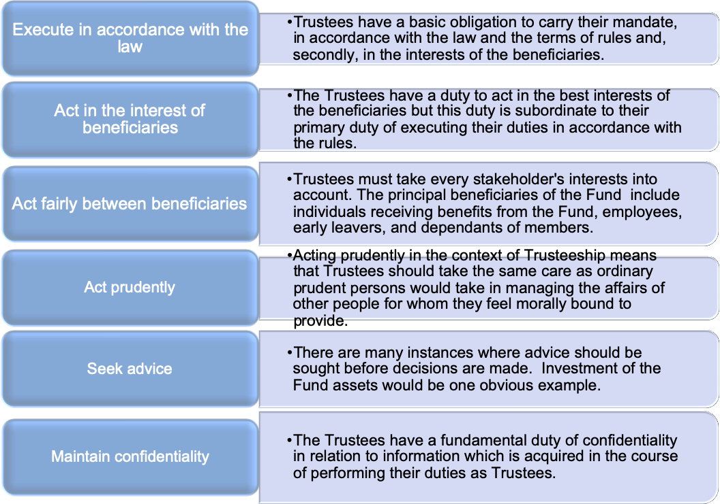

Fundamental Principles of retirement funds
Principle 1 – Retirement funds are separate legal entities. | The fund is separate from the sponsoring body, be it the employer, union, or service provider. It can sue and be sued in its own right.
Principle 2 – Trustees make decisions | The fund is directed, controlled, and overseen by the Board of Trustees (Management Board), including good governance, administration, management of service providers, and the designing of benefit structures usually with the help of the Fund Consultant.
Principle 3 – The Fund rules are king | Trustees are not permitted to do anything outside the registered rules of the fund. All benefits and contributions should be in terms of the rules and the Pensions Funds Act. However, Trustees have limited discretionary powers in some instances especially where the rules are silent.
Principle 4 – Membership to the fund is compulsory for all eligible employees | An organization that has a retirement fund must make it a condition of employment for all new employees that join the organization, as long as they meet the eligibility criteria.
Principle 5 – Funds are designed with the sole purpose of providing retirement benefits and/or risk benefits. | The sole purpose of a retirement fund is to provide retirement benefits; all other considerations are secondary to this duty. Trustees should, therefore, ensure that provisions are in place to safeguard this requirement.

4.3 Who may act (Selection and appointment of Trustees)?
Other than certain persons listed below who are prohibited by law from acting as Trustees, any individual, provided the rules allow, may act as a Retirement Fund Trustee. As this is a position of responsibility, an individual’s qualification, experience and character traits of honesty and integrity are critical factors to consider in the selection of a Trustee.
4.3.1 Types of Trustees
Member-elected Trustees | Those Trustees elected by the fund members.
Employer-appointed Trustees | Those Trustees appointed by the employer.
Professional / Independent Trustees | Independent Trustees are those Trustees who are not employed or controlled by the employer or its employees or any organization which acts on behalf of members of the fund. Independent trustees are usually appointed to Umbrella funds where there is a need for an independent opinion as the administrator/sponsor appoints Trustees.

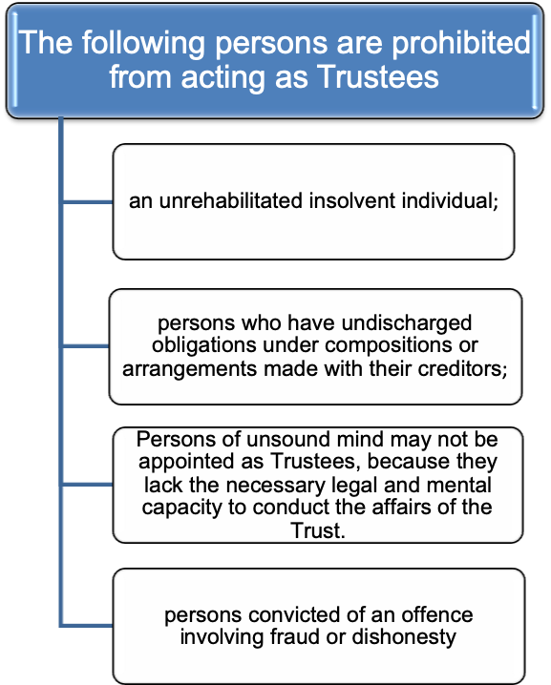

Note: that once Trustees have taken up the office they can be held jointly and severally liable for the decisions of the fund despite being elected or appointed as stated above.

4.4 Managing Conflict of interest in Retirement Funds
4.4.1 Definition
Conflict of interest is defined as any situation that has the potential to undermine the impartiality of a person because of the possibility of a clash between the person’s self-interest and professional interest or public interest.
Conflict of interest should not necessarily prevent Trustees acting in good faith. In situations where Trustees are conscious of a possible conflict of interest, it may be necessary, before a decision is taken, to obtain legal or other professional advice, as appropriate.
Any persons appointed as Trustees could be in a position where there may be a conflict between their duty as a Trustee and their other interests. Their duty as a Trustee must prevail when making decisions.
Conflict of interest cannot be avoided totally but needs to be acknowledged and managed accordingly.
Examples of Conflict of Interest
- Trustees appointed directly by the employer may include members of the companies’ board, senior management such as Finance and Human Resources Executives. Such persons may experience a conflict of interest between their duties to the company and their duty as Trustees, as they seek to balance the two roles. This could arise for example where the company is experiencing financial difficulties and where consideration is being given to a proposal of a loan to the company.
- Conflict of interest may also arise in the case of Trade Union officials acting as Trustees, where they could believe they are appointed to represent a particular faction or group.
- Trustees may also include members of the fund. Such persons may experience a conflict of interest concerning the payment of benefits where the Trustees have discretion and their colleagues are involved.
Trustees are not to profit from the fund
A clear conflict of interest would arise if a Trustee profit from the assets of the fund or from the decisions they make. Trustees should not make a profit from their fund, whether directly through being paid for their work, or indirectly through using information gained as Trustees for their ends unless rules specifically provide that the Trustees may be paid for carrying out their duties.
Trustees are to be reimbursed for costs incurred while carrying out Fund business.

4.5 Trustee liabilities and protection
Section 7F of the Pension Funds Act affords Trustees protection from liability
“In any proceedings against a board member in terms of this Act, other than for wilful misconduct or wilful breach of trust, the court may relieve the board member from any liability, either wholly or partly, on terms that the court considers just if it appears to the court that —
- the board member has acted independently, honestly and reasonably; or
- having regard to all the circumstances of the case, including those connected with the appointment of the board member, it would be fair to excuse the board member.”
Breach of Trust
If Trustees act in a way not authorized by the rules, or if they fail to do something which should have been done under the same provisions, this is called a breach of Trust. All the Trustees are individually and collectively liable for any breach of Trust. Even if a Trustee were not directly responsible for a breach of trust, he or she could be sued. If it is found that the Trustees have committed a breach of Trust which results in a loss of fund assets or prejudice to any stakeholder, they will be personally liable to restore the loss. However, a mere error of judgment is not in itself a breach of Trust and Trustees are presumed to have acted honestly and properly until the contrary is shown.
Protection for Trustees (Fidelity Insurance)
If a breach of Trust does result in a loss to the fund, and a claim is lodged against the Trustees, they may rely on the protection afforded by any relevant statutory provisions or by an exclusion clause or indemnity clause contained in the rules. If their defence is unsuccessful, the fund’s fidelity policy should indemnify them against claims
Most funds take out insurance against Trustees’ liabilities. It is essential to take advice however, from a specialist who understands this type of insurance. It should be noted that though a Trustee may be legally removed, he or she remains liable for any decisions they took when acting as Trustee. It is therefore important, from the Trustee’s perspective, that any indemnity insurance will cover them for a suitable period after they have ceased to be a Trustee.
Fidelity Cover - This is a short-term insurance policy, which provides against losses caused by wrongful acts of officials of an organization in carrying out their duties.
In retirement fund terms it is (generally) insurance against losses incurred by the fund, and hence the members, as a result of people who have access to contributions or fund assets helping themselves (fraud, theft), but could also cover such things as benefits paid to the incorrect party which cannot be recovered.
In terms of the Pension Funds Act, funds are required to affect a policy of insurance to indemnify the fund against losses due to the dishonesty or fraud of any of its officials. The limits of indemnity and levels of cover are not prescribed and the Trustees need to make decisions regarding these issues themselves.

4.6 PF Directive 8 - Prohibition on the Acceptance of Gratification
Summary:
- Officials of and service providers to a fund must not be involved in any conduct constituting bribery, fraud, or corruption, and any such involvement will have a bearing on such person’s fitness and propriety to hold office.
- Issues that may prejudice a fund or its members must be reported to the Registrar.
- Corrupt transactions must be reported to the police.
- The Directive defines what constitutes ‘gratification’.
- The defined types of gratification may not be accepted at all by fund officials and service providers unless the Registrar agrees in advance they can be accepted.

General Principle
A board member, principal officer, deputy principal officer, an employee of a fund, auditor, evaluator, administrator, an employee of an administrator or service provider to a fund, including investment managers and investment advisors should not be involved in any conduct which constitutes bribery, fraud or corruption.
What qualifies as “gratification” in Directive 8?
Gratification means:
- Money, whether in cash or otherwise;
- Any donation, gift, loan, fee, reward, valuable security, property or interest in the property of any description, whether movable or immovable or any other similar advantage;
- The avoidance of a loss, liability, penalty, forfeiture, punishment or other disadvantages ;
- Any office, status, honour, employment, contract of employment or services, any agreement to give employment or render services in any capacity and residential or holiday accommodation;
- Any payment, release, discharge or liquidation of any loan, obligation or other liability, whether in whole or in part;
- Any forbearance to demand any money or money’s worth or valuable thing;
- Any other service or favour or advantage of any description, including protection from any penalty or disability incurred or apprehended or from any action or proceedings of a disciplinary, civil or criminal nature, whether or not already instituted, and includes the exercise or the forbearance from the exercise of any right or any official power or duty;
- Any right or privilege;
- Any real or pretended aid, vote, consent, influence or abstention from voting; or
- Any valuable consideration or benefit of any kind, including any discount, commission, rebate, bonus, deduction, or percentage.
- Gratification excludes any remuneration paid by a sponsor of a fund to a trustee appointed by the sponsor of a fund.

4.7 Trustee qualifications and experience
As stated in the Introduction, Trustees are generally drawn from company managers and other employees. Trustees may not possess the necessary expertise to carry out all of their specified duties without the assistance of qualified advisers. A particular example is the investment of fund resources. Trustees of a fund are required to possess, or employ, or enter into arrangements with advisers who possess qualifications and experience appropriate and relevant to the investment of the fund resources. Trustees are regarded as executing their duties by appointing an investment manager to manage the investment of those resources.
Global Retirement assets are estimated to be worth over US$46 trillion (Dec 2017, Towers Watson), with the assets to GDP ratio being over 120% of GDP in the developed world. With Trustees being the directors of such huge assets, it is critical that the Trustees be sufficiently qualified and experienced to make the right decisions for their members.
Some interesting quotes:
“Trusteeship today requires significant expertise, yet many have identified trustees as being the weakest link in the value chain” NAPF Discussion Paper, 2005)
“Trustees are a mass of well-intentioned but not necessarily expert folk” and have represented a “residual enclave of amateurism in . . . business life” (J Plender, Financial Times, January 2005)
The Organization for Economic Co-operation and Development (OECD) recognizes this need and recons that Trustees “should be subject to minimum suitability standards to ensure a high level of integrity, competence, experience, and professionalism in the administration of the pension fund.
The Board should collectively have the necessary skills and knowledge to oversee all functions performed by a pension fund, and to monitor those delegates and advisors to whom such functions have been delegated”.
The Financial Sector Conduct Authority published a draft Conduct Standard for determining the minimum skills and training requirements for board members of pension funds.
The draft Conduct Standard prescribes the minimum skills and training requirements for board members of funds as contemplated in section 7A(3)(a) of the Pension Funds Act, 1956. This section requires the trustees (board members) of pension funds to attain the levels of skills and training within six months after being appointed to such a position that may be prescribed by the Authority. Section 7A (3) (b) goes further to state that board members must maintain their skills and training throughout their term of appointment.
The Trustee Toolkit which is provided for by the Authority on the website www.trusteetoolkit.co.za is the prescribed minimum skills and training requirement envisaged in section 7A(3)(A) of the Act.
The Trustee Toolkit provides the foundational knowledge of the legislative environment, fund governance, fiduciary duties of board members, responsibilities, and obligations of board members towards the fund and its members and fit and proper conduct by board members.
Board members are required after certification to complete any additional modules that may be added by the Authority. The draft Conduct Standard proposes the following:
- The Conduct Standard will take effect on 1 January 2020;
- Trustees appointed on or before 1 January 2020 - to complete by 30 June 2020.
- Trustees appointed on or after 1 January 2020 – to complete within six months and under the supervision of the Principal Officer or the Chairperson.
- Trustee Toolkit is the minimum training Trustees must undergo (regardless of any other training a Trustee may already have undertaken).
- Any additional modules added after completion must be undertaken by Trustees afterward.
- FSCA will keep records of everyone who completed the training and assessments.
- A person who has completed the Toolkit certification and is subsequently appointed to a board of a fund is not required to complete the certification again.
4.7.1 Training for Trustees
The following are areas that a Trustee should be well versed in;
Pension Law / Marriage Act / Divorce Act / Child Maintenance Act / Taxation / Investment Regulations
Life Stage Investments / Individual Member Choice / Single Manager / Multi-Manager / Alternative Investments

Corporate Governance / Risk Management / Environmental / Socially Responsible Investments

Financial Statements / Actuarial Valuation Report / Investment Reports / Administration Reports / Death benefit distributions

Pensions are a difficult and complex area. Trustees should ask questions where they are unsure of any issue. The most important and effective way to ensure successful Trusteeship is through suitable Trustee Training.
The responsibilities of Trustees, the implications of the fund’s rules, and a basic understanding of the fund’s finances, fund investments, fund governance, and fund reports should be covered in such training. This in turn will make Trustees aware of the background law, and give them a good knowledge base to enable them to carry out their duties in an efficient manner without unnecessary worry. It should also help to minimize the Trustee’s exposure to legal liability.

In most countries, minimum qualifications are now being imposed to ensure that Boards are sufficiently equipped.
Where possible, independent and professional training should be engaged rather than relying on pension fund service providers to provide training because there is an inherent conflict of interest as training may be restricted only to products and services offered by the specific provider. Trustees may thus not have an overview of the entire market and available options.
4.7.2 Costs of Training
Trustees should be aware that it is acceptable that reasonable costs and expenses incurred in receiving appropriate training on their duties and responsibilities as Trustees should be met from the resources of the fund, as this is meant to improve the efficiency in the running of the Fund and not for personal gain.

4.8 Trustee decision making
In practice, Trustees are expected to make prudent decisions about the management of the fund and in particular, must give express effect to the provisions of the rules. Trustees will also need to be conscious of areas where decisions to be taken are at the discretion of the Trustees solely, or require input from another party, such as the employer. It is also possible that the rules may specify a requirement for consultation with a third party before making a decision. Sometimes the views of the members and employer may be very relevant to the matter in hand e.g. securing benefits on wind-up which would affect members or making a decision to change the employer contribution rate which would affect the employer. Such factors should be taken into account by the Trustees when reaching a decision.
Trustees should exercise their judgment and not automatically act in accordance with the wishes of the employer or any group of members, or even of all the members. That is not to say that Trustees should ignore the views of the Employer or the members; they should listen to them carefully, but in the end, they should make up their minds as to what will best serve the interests of the fund.
4.8.1 Majority or unanimous decision
Trustees should act collectively, and each Trustee must take account of the views of others and seek a consensus. The rules usually provide that, in making decisions, the view of the majority will prevail over that of the minority.

4.9 Delegation of Trustee powers and duties
No Trustee can carry out all of the functions and day-to-day administration tasks. Trustees will, therefore, be expected to delegate.
Trustees, however, remain responsible and accountable for the execution of the delegated task be it administration, investments, legal or actuarial services rendered on behalf of the fund. Trustees must, therefore, take great care in selecting the person or organization to which they delegate a specific function and must monitor and review the actions of that person or organization.
Depending on the nature and circumstances of the fund, typically the other functions delegated to a third-party administrator would include the following (this list should not be taken as exhaustive):
- Drafting and registration of the fund rules with the Registrar and payment of the relevant fees;
- Collection and payment of contributions to the appropriate party;
- Investment and custody of the funds’ assets;
- Where applicable, preparation and maintenance of the investment policy statement;
- Payment of benefits;
- Furnishing of information to the actuary/auditor in connection with the actuarial valuation and audit of accounts;
- Deduction/payment of tax on benefits to the Revenue Authority;
- Seeking advice from the Actuary where required under the rules;
- Distribution of death benefits.
Trustees may delegate only to the extent that they are empowered to do so by the rules of the fund.
Trustees should take great care in selecting the person or organization to which they delegate a specific function and should monitor and review the actions of that organization at regular intervals. Trustees should put a Service Level Agreement in place when delegating any of their functions to any person or organization.

4.10 Conducting Trustee meetings
The Trustees’ meeting is one of the most important methods by which Trustees discharge their functions. Trustees need to hold regular meetings to review the operation of the fund and supervise the actions of the administrators, investment managers, and advisers to whom they have delegated many of their functions.
The Trustees meeting also serves as the main forum for Trustees to exercise their discretionary powers where the rules are not specific about the course of action Trustees should take in reaching a particular decision, or where the Rules give Trustees discretionary powers.
4.10.1 Frequency and timing of meetings
The rules normally specify how often Trustees must hold Trustee meetings. but if not, it is a matter to be decided by the Trustees, having regard to the circumstances. The Trustees of all funds need to meet sometime after the fund year-end to consider such items as the Trustee annual report, the fund accounts and perhaps auditors’ report, report from the investment manager, etc. Other items such as the need to exercise discretionary power following the death of a member could require a meeting at any time of the year. The size and complexity of the fund may also be factors in deciding how often Trustees need to meet. As an absolute minimum, Trustees should meet twice a year.
4.10.2 Meeting structure
The agenda for the Trustees meeting will contain a summary of the main points for discussion at the meeting which will be dictated by the needs of the fund. The agenda will usually be prepared by the Secretary of the Board of Trustees.
A typical agenda might look something like this:
- Circulation of Attendance Register
- Confirmation of Quorum
- Minutes of the previous meeting – for approval
- Matters arising from the previous meeting
- Administrator’s Report
- Fund Finances - Financial Statements, cash flows, and Actuarial Valuation Report
- Investment Manager’s Report and Review
- Legal and compliance matters
- Fund policies
- Discretionary matters – Industry updates.
4.10.3 Recording decisions
Any decision at a meeting requires a quorum to be present and the rules should specify how many Trustees have to be present to form a quorum.
The notice of the meeting, agenda, and full supporting paperwork should be distributed by the secretary ideally at least seven days before each meeting but in any event in time to allow the Trustees to prepare themselves for the meeting.
The Trustees should also ensure that all decisions are properly minuted and distributed to all relevant stakeholders.

4.11 Removal / Suspension of Trustees
Trustees can be removed in cases where;
- They have failed to comply with the duties imposed on them by law,
- They have been convicted of criminal activities,
- They have left the employer.
- The fund is being or has been administered in such a manner as to jeopardize the rights and interests of the members of the fund. Under these circumstances, the Registrar has the power to suspend the Board of Trustees and appoint an interim Board of Trustees,
- They fail to meet the minimum qualification and experience requirements set by the Registrar,
- They are not re-elected or re-appointed.

Chapter 5

Investing Retirement Fund Assets
Good knowledge of this chapter will ensure competency in the following specific outcomes:
- Explain the role of Trustees in Investing fund assets
- Explain what an investment portfolio is
- Discuss the provisions of Regulation 28 and its impact in an investment of fund assets
- Describe the active and passive asset management philosophy
- Discuss the investment fundamentals for retirement fund assets
- Discuss how a board comes up with an investment policy for the fund
- Explain the different investment vehicles used by retirement funds
- Describe the different portfolio structures that the board could adopt in investing assets
- Discuss the various aspects that the board should consider when appointing an investment manager and on replacing a manager
- Explain how the board can monitor the performance of the fund's investments
- Explain the importance of sustainable investments.

5.1 The Trustee's duty to invest fund assets
The fund’s main objective is to provide members with meaningful retirement benefits and as such the Trustees are responsible for the investments of the fund especially under defined contribution funds where the members carry the investment risk.
Trustees have to ensure that the fund's assets are invested in a way that complements and is consistent with the ability of the fund to meet present and future liabilities within the confines of the investment regulations applicable.
The Trustees may delegate the technical aspects of this duty to an asset manager, but it remains the overall responsibility of the Trustees to ensure that the fund meets its objectives, which is to achieve real investment growth over the long term but also to actively manage the risk of loss of assets in the short term.
The Trustees must continuously monitor investment returns and exposure to risk, and attempt to achieve an optimum balance between the risk and the return. If Trustees find that investment has become unsound, too risky, or simply does not provide an adequate return, it would be their duty to disinvest and seek better alternatives, ensuring that proper arrangements are made to allow the best possible returns in the interim, should this be necessary.

5.2 Investment Portfolio
5.2.1 What is an Investment Portfolio?
An Investment Portfolio is a combination of different types of asset classes. A portfolio can have portions invested in various asset classes or investments such as shares, property, alternative investments, bonds, and cash.
A balance of the different asset classes is required to provide the best returns at the best possible level of risk. It is this blend of the different asset classes that will constitute the fund’s investment portfolio.
We will focus our attention on the different asset classes to briefly understand their description and important characteristics.

Type of Asset | Description
Shares / Stocks | Represent shares of ownership in publicly held companies  Historically have outperformed other investments over long periods (keep in mind that past performance does not guarantee future results).  Most volatile asset class in the short term  Returns and principal (capital assets) will fluctuate so that accumulations, when redeemed, may be worth more or less than the original cost.
Bonds | Bonds are interest-bearing investments, but usually involve a longer period to maturity, typically 5, 10, 20 or even 30 years. Governments, local authorities, parastatals, and corporates borrow money from investors by issuing debt instruments called bonds.  By holding a bond an investor is usually entitled to an annual cash interest payment that is fixed at the time of purchase. While this locked-in interest rate may seem safer, it exposes the investor to more risk: if inflation or short-term interest rates go up during the period to maturity, the investor loses out.  Bonds are low to medium risk investments and provide low to medium returns over time.
Money Market | There are several money market instruments, including treasury bills, commercial paper, bankers' acceptances, deposits, certificates of deposit, bills of exchange, repurchase agreements, and asset-backed securities.  The instruments bear differing maturities, currencies, credit risks, and structure and thus may be used to distribute exposure.
Property | Covers the whole ambit of real estate investment, from rural estates to office blocks. It is a medium to a high-risk asset class, with returns proportionate to this risk.  The property market is generally adversely affected by rises in interest rates; it tends to have a low correlation with interest-bearing investments - especially cash.
Alternative Investments | Alternative investments include venture capital, private equity, hedge funds, real estate investment trusts, commodities as well as real assets such as precious metals, rare coins, wine, and art.  These assets usually perform with low correlation to stocks and bonds, may be difficult to value, and are generally more illiquid than traditional investments.
Private Equity | Private equity consists of investors and funds that make investments directly into unlisted companies (private companies).
Hedge Funds | A hedge fund is an investment fund that pools capital from a limited number of institutional investors and invests in a variety of assets, often with complex portfolio construction and risk management techniques.  Many hedge fund investment strategies aim to achieve a positive return on investment regardless of whether markets are rising or falling but come at a cost for such protection.
Commodities | Physical goods such as gold, copper, crude oil, natural gas, wheat, corn, and even electricity.  Helps protect future purchasing power as values have fixed utility and thus run parallel to inflation  Values tend to exhibit low correlations with stock and bond prices.
Foreign Assets | These are investments in any of the above assets in markets outside your own and usually in a different currency

A typical fund portfolio could be constructed as below;

5.3 Regulation 28 – Guidelines on Retirement fund Investments
The investments of the Pension Funds are mandated to be managed within the prescribed limits set in Regulation 28. Regulation 28 provides guidelines on how different asset classes can be utilized by retirement funds in investment portfolios and the maximum exposure per asset class. The table below summarises Regulation 28 provisions:
Summary of Regulation 28
Asset Class | Maximum %
Shares | 75
Any listed company | 15 (Dependant on Market Capitalisation)
Private Equity | 10 (Subjects to limits)
Property | 25 (Dependant on Market Capitalisation)
Interest-bearing investments | 75 (100% if guaranteed by the Republic)
Global investments (excl Africa) | 30
Africa foreign investments | 10
Commodities | 10 (Gold) -5 (Other)
Hedge Funds | 10 (Subject to limits)
Hedge Funds and Private Equity | 15
Other Assets | 2.5

The Fund should request a certificate, from the respective investment managers confirming that the assets complied with Regulation 28 limits, provided that the auditors of the respective asset managers confirm the accuracy of such certificates, which shall be presented to the Trustees on an annual basis and also forms part of the Fund’s audit points.

5.4 Portfolio Management Styles
The art of selecting the right investment policy for the individuals in terms of minimum risk and maximum return is called portfolio management.
They are predominantly active and passive portfolio management styles.
The choice will largely depend on the economic environment in which the investments are being done. In some cases, a blend of the two styles gives the best blend. The Trustees with the help of the Investment Consultant will determine what suits the fund in the particular economic environment.
Below is a brief description of each of the styles;
Active Portfolio Management | As the name suggests, in an active portfolio management service, the portfolio managers select financial securities to outperform an index by buying and selling of securities to ensure maximum profits.  Active managers rely on research, forecasts, expert judgment, and experience in making investment decisions on which securities to buy, hold, and sell.
Passive Portfolio Management | Passive investing (also known as “Indexing”) entails selecting financial securities that mirror the performance of an index or benchmark of interest. Passive investment followers believe in the Efficient Market Hypothesis. …which states that the prices of financial securities incorporate and reflect all publicly available information at all times. There are no mispriced securities.  Passive investing works well in an investment environment that has good informational efficiency. This is also known as the strong form of the Efficient Market Hypothesis.  A perfect market is where all the information relating to an instrument is priced into that instrument.  If the price of a share reflects the true valuation of that instrument, then there is no purpose in analysing that share to take advantage of any mispricing.  As such the fee paid for active management will not yield any excess returns (net of fees) over and above an index. Therefore, investors in such environments should simply invest in the index.  In passive portfolio management, the portfolio manager deals with a fixed portfolio designed to match the current market scenario.  Ways of tracking an index  - Full replication – holding all the constituents in proportion to their index weightings (e.g. market capitalisation)  - Sampling / Partial replication – holding a sample of securities that behave in the same way as the index (e.g. SWIX Top 40 to mirror the performance of the ALSI)  - Synthetically replicating the index using derivatives – holding a portfolio of futures/options and cash  Index tracking – advantages (+)/disadvantages (-)  - Reduced risk of underperforming the index  - Lower dealing and research costs  - Impossible to systematically outperform in an efficient market  - Diversification is achieved if the index is well-diversified  - The fees charged mean you are likely to underperform the index  - In a fully replicating strategy, you are a forced trader when the constituents change  - It may prove difficult to find an appropriate index to track (Private Equity, Direct Property, Hedge Funds.)  - May pay insufficient regard to the Fund’s investment objectives (Social impact of investments; ESG factors)  - An index is constructed on BIGGER is BETTER  - No regard for Downside Risk Management in times of poor market performance and market crashes

Factors to consider when deciding on an approach
- Level of market efficiency
- Economic cycle
- Investment objectives of the Fund
- Level of diversification of the index
- Cost of the strategy/approach
- The expertise of portfolio/asset manager
- Liquidity of the Index
- Regulation (explicit/implicit requirements)
- Social impact/ ESG.
Core /satellite approach
This entails adopting both passive and active investment management approaches to enjoy the different attributes of each approach.
A percentage of the Fund, the “CORE” portfolio, is managed on a passive, low-cost basis, and specialist managers appointed to manage the rest of the Fund, the “SATELLITE” portfolio. The split between the two will largely depend on the perceived market efficiency and Fund objectives.
The actively managed part of the Fund will then be invested in assets with largely different risk / return characteristics to those of the core portfolio. This will typically be the Private Equity, Hedge Funds, and Alternative Investments space which will not be affected by the factors affecting the main indices.

5.5 Key Investment Fundamentals for Retirement funds
Fundamental 1: Retirement investments are long term
Retirement savings essentially have a horizon of 40 years to maturity which is crucial in considering the portfolios’ investment strategies. Trustees should, therefore, design portfolios that beat inflation by significant margins over the long term to retain real value in member benefits. It is essential therefore to carry some degree of risk.
The major determinants of asset allocation are the time horizon to retirement and the investment risk profile of the portfolio.
- Time Horizon - is the expected duration of the investment. An investor with a longer time horizon may feel more comfortable taking on a riskier or more volatile portfolio. When retirement fund portfolios are constructed, they are done taking into account the demographic profile of the fund. Usually, there are special portfolios that are designed to protect member’s assets when they are close to retirement.
- Risk Tolerance - is the willingness to experience both positive and negative returns on the portfolio assets. There are essentially three classes of investors i.e. an aggressive investor, a conservative investor, and a moderate investor.
Investment Fundamental 2: Shares outperform the other asset classes over time
History has shown that in the long run the equity market rewards an investor with inflation-beating returns, but to be able to reap the rewards the investor must be able to tolerate short-term volatility. We will use the Johannesburg Stock Exchange, Bond market, and Inflation to show this because of its stability over the years.
The stock market has the highest volatility in the short-term and Trustees and members must be aware of this characteristic. It is therefore important to note that this is a crucial investment for the Fund to achieve its long-term growth objectives. The lower the allocation to shares, the lower the probability of achieving long-term returns above inflation.
You will notice from the graphs that over the long term (10 years or more), it is not favourable to invest only in fixed interest, bonds, and cash because these investments do not provide the returns that shares do, although, over the shorter periods, the returns from these portfolios are not as volatile as shares.
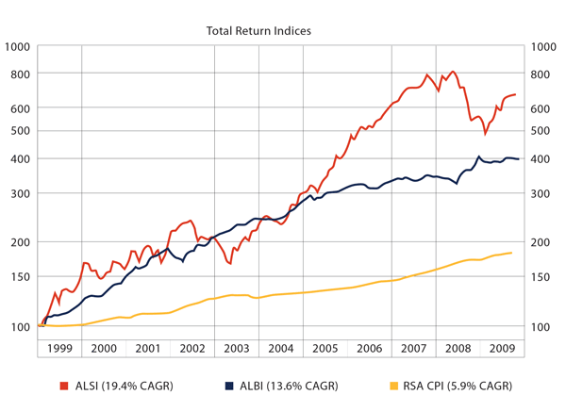
When one considers an even longer period in this case for 80 years, the outcome is much the same in that shares provide the best long term return than the other types of asset classes.
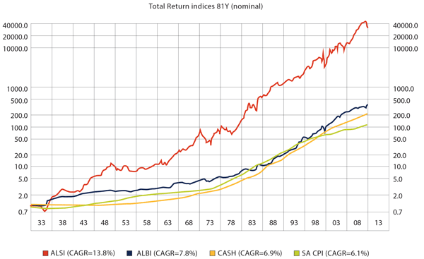
It is for this reason that the Trustees of the Fund offer portfolios with a high equity (share) content especially for younger members who still have a long time horizon (time to retirement) and who can take on additional investment risk.

Fundamental 3: There is no reward without risk

When it comes to investing, risk and reward are very closely linked. You have probably heard the phrase "no pain, no gain" - those words come close to summing up the relationship between risk and reward. Do not let anyone tell you otherwise. All investments involve some degree of risk. Over the long term, even cash has an element of risk because the returns of a cash portfolio may be below inflation which means that the purchasing power (how much you can buy with your money) is going down.
The reward for taking on risk is the potential for a greater investment return. If you have a financial goal with a long time horizon, you are likely to make more money by carefully investing in asset categories with greater risk, like shares or bonds, rather than restricting your investments to assets with less risk, like cash equivalents.
Fundamental 4: Diversification is key;
Diversification is a strategy that can be best described as "Don't put all your eggs in one basket." The strategy involves spreading your money among various investments (Shares, Bonds, and Cash) in the hope that if one investment loses money, the other investments will more than make up for those losses.
The practice of spreading money among different investments to reduce risk is known as diversification.
By including different asset classes with investment returns that move up and down under different market conditions within a portfolio, an investor can protect against significant losses. Historically, the returns of the three major asset classes (shares, bonds, and cash) have not moved up and down at the same time. If one asset class's investment return falls, you will be in a position to counteract your losses in that asset category with better investment returns in another asset category.
Also, asset allocation is important because it has a major impact on whether or not you will meet your financial goal at retirement. If you do not include enough risk in your portfolio, your investments may not earn a large enough return to meet your goal.
Some financial experts believe that determining your asset allocation (by selecting the appropriate investment portfolio) is the most important decision that you will make concerning your investments. With that in mind, you may want to consider asking a financial professional to help you determine whether your investment portfolio is appropriate for your fund.

5.6 Investment Policy Statement
Trustees should agree on appropriate investment policy for the fund and where relevant, place limits on the fund’s investment in specific sectors, markets, shares, and other securities. In the case of a Defined Benefit fund, the employer must be consulted on investment policy. Trustees must ensure that the Investment policy statement complies with the applicable investment regulations and their investment strategy accordingly.
Concerning the investments of the fund, Trustees must invest with the care which an ordinarily prudent person would take in investing for the benefit of other people for whom he/she felt morally bound to provide. As the purpose of the fund is the provision of benefits for members and other beneficiaries Trustees must invest solely in their best interests. In this context “best interests” should be taken to mean the best financial interests. Trustees must also invest the assets of the fund in a manner appropriate to the circumstances of the fund, i.e. they must review the general circumstances, such as the age profile of the members of the fund and invest the assets appropriately.
The basic requirements are that;
The assets of the fund must be invested in a manner designed to ensure the security, quality, liquidity, and profitability of the portfolio as a whole so far as is appropriate having regard to the nature and duration of the expected liabilities of the fund.
The Trustees must invest the assets of the fund predominantly in regulated markets. Investments in assets not admitted to trading on a regulated market must be kept to a prudent level.
The assets of the fund must be properly diversified to avoid excessive reliance on any particular asset, issuer, or group of undertakings.

Guidelines for determining the investment strategy of the Fund
Investment Objectives
Measure risk and returns
Regular feedback
Determine Risk profile
Determine Benchmark for fund
Design mandates + individual benchmarks
Review Investment Products
Due diligence checks

5.7 Statement of Investment Policy Principles (“SIPP”)
Even where the Trustees appoint an investment manager, they remain responsible to the beneficiaries for the investment of the assets of the fund.
Elements that the SIPP should contain are:
Fund Investment objectives: | For Defined Benefit and Defined Contribution Funds where no member investment choice is available, the Trustees would expect this to include the objectives of meeting the liabilities and the attitude to risk. For other Defined Contribution funds, the Trustees would expect it to include a description of the rationale for the investment choice made available to members.  The fund’s investment objectives must be unambiguous, measurable, and must reflect the risk tolerance level of the fund. The investment objectives set by the Trustees will inform the choice of asset managers which will be appointed to manage the fund.
Measurement of investment risk | The Trustees expect that this would identify the investment risks faced by the fund and how these risks are measured.  Different funds use differing approaches toward measuring risk, and no one approach is prescribed. Defined Contribution funds may choose to provide a separate response for each investment fund.
Risk management processes to be followed | The Trustees would expect this section to describe how the fund Trustees manage on-going investment risk.  There are many possible approaches, but for example, the SIPP may include the guidelines provided to the investment managers, and a policy statement relating to periodic reviews of investment performance and risk. Again, Defined Contribution funds may provide a separate description for each fund.
Strategic asset allocation | For Defined Benefit Funds the Trustees would expect a statement of the asset allocation strategy and how the nature of the liabilities of the fund have been taken into account in setting it. For Defined Contribution funds, the Trustees would expect this section to include a description of the investment funds made available, along with any restriction on member investment choice.

5.8 Investment Portfolio Structures
5.8.1 Pooled funds
These are investment portfolios in which several investors pool their assets so they can be managed on a collective basis. Shares in a pooled fund are denominated in units and are re-priced regularly to reflect changes in underlying assets. This allows investors to value their holdings regularly.
This is the umbrella fund equivalent of investments.
5.8.2 Segregated funds
These are investment portfolios that are managed on behalf of a single client and have separately identifiable assets.
Segregated funds are traditionally investment portfolios that are held directly in the investor's name and hence segregated or separable from the assets of all other clients or pooled funds. In other words, segregated portfolios are individually managed mandates which operate according to the unique criteria, guidelines and constraints agreed with and specified by the client.

5.9 Investment Vehicles available to Retirement Funds
5.9.1 Guaranteed Funds
Guaranteed fund portfolios are generally only offered by life Insurers and relieve the Trustees of some of the investment risks. The guarantee provided under these types of portfolios means that regardless of the market values of the underlying assets, the Insurer guarantees that the fund will be paid a certain nominal value.
In other words, there is an attempt to even out the peaks and troughs of investment returns and also retain a margin to allow for future uncertainties. As such, these portfolios are particularly suitable for funds with a low-risk appetite, small funds, a large number of members nearing retirement, and funds with erratic cash flows. Funds with the above profiles would not tolerate negative movements in market values.
The Guaranteed Fund offers capital guarantees and low volatility, whilst still achieving superior competitive returns over the long term. Investment returns are distributed through bonuses declared yearly or monthly by the Insurer. In good years, a reserve is created, by holding back some of the returns; the reserve will be used to supplement returns in bad years. Volatility is therefore reduced.
Functionality
- Market volatility is removed through smoothed bonuses.
- Bonuses are declared monthly / annually in arrears and consist of a vested and a non- vested portion.
- All capital invested and vested bonuses, once declared, are guaranteed.
Key Features
- Provides investors with a guarantee on all capital invested and vested bonuses declared.
- Distributes investment earnings by way of smoothed bonuses.
- Diversified underlying portfolio.
- Long term real return.
5.9.2. Market-linked Funds
With a market value investment (managed/direct investment), there can be no question of hidden reserves as market fluctuations are immediately reflected in the value of the portfolio's assets. The asset manager provides no guarantees and the fund experiences the full volatility of the market.
The essential advantage of the managed fund portfolio is that it provides the fund with full participation in investment returns – concurrently however, there is the corresponding volatility.
The disadvantages, in comparison to the guaranteed portfolio, are that there are no guarantees of investment values and hence, if the Trustees or members do not fully understand the fluctuation of market values, they may distrust the fund manager.
The market-linked portfolios are normally named after their volatility and risk exposure.
Typical names and descriptions are as illustrated below;
Aggressive | Aggressive portfolios typically have relatively high exposure to equity investments (shares). | Typically targets return objective of CPI plus 7.0% over a rolling 3 year period.
Moderate | These portfolios are suitable for long-term investors who seek reasonable growth but require less volatility than can be expected with aggressive portfolios by reducing equity exposure. | A target return objective of CPI plus 5.0% over a rolling 3 year period.
Absolute Return | These portfolios are suitable for the funds which seek reasonable growth but wish to preserve capital over the short term.  Fluctuations are less likely, but as the risk of the short term negative returns is reduced, the long term performance is expected to be lower than that of moderate and aggressive funds. | Targets usually set over a 12 month period.
Conservative | These portfolios offer capital guarantees with reduced volatility relative to moderate and aggressive portfolios.  Whilst the risk of capital loss and fluctuation of returns is reduced, the long-term return expectation is lower than the other portfolios. | A target return objective of CPI plus 3% over a rolling 3-year period.

5.10 Investment approaches used by Funds
- Single Manager Approach | The assets are all invested in a single portfolio. The performance of the fund is therefore directly dependant on the performance of the appointed manager and the selected investment portfolio.
- Multi Managers Approach | Multi-manager investing is a simple concept that aims to deliver returns and manage risk. Unlike a traditional fund, in which a single fund manager controls all of the money and investments in a fund, multi-manager portfolios spread the assets across different asset types and fund managers. By not putting all your eggs in one basket, this helps in diversifying the investment portfolio and reduces exposure to risk.  In single manager portfolios, if the investment does not perform as well, the Trustees have two options: hope that the fund manager gets its act together; or cut your losses and look for another fund in which to invest.  Multi-manager investing, on the other hand, relies on lots of different fund managers, picked by a professional team. The overall performance is expected to be better in the long term.  A Multi-manager approach allows a high degree of diversification, in terms of both a large number of underlying stocks and a range of investment styles and strategies.  In this way, a portfolio of funds can both enhance investment performance through superior stock and bond picking skills, whilst reducing risk through an appropriate diversification of assets, strategies, and styles.

5.11 Fund Investment Designs
5.11.1 Single portfolio for all members (One size fits all)
All the assets of the fund are invested in the same portfolios without regard to the different ages, financial literacy, risk appetite profile, and special needs of the individual members. The Trustees will select the portfolios that they believe will offer the best returns. This can be used especially where the fund has a lot of young members and would not be viable to create other portfolios for the other age groups or where the portfolio is too small to be split up.
5.11.2 Life Stage investment approach
A Life Stage strategy is a customized investment strategy, designed taking into account the member’s age and therefore expected time to retirement to maximize the post-retirement income of retirement fund members, whilst taking into account the risk profile of the age group. A fund could thus be divided into three bands as exemplified below, assuming a retirement age of 65 years;

Growth Stage | Consolidation Stage | Preservation Stage
18 – 55 years | 56 – 62 years | 63 – 65 years

To earn inflation-beating returns over time, it is necessary to have exposure to growth assets such as equity. However, equities are highly volatile. As members approach retirement, their ability to withstand significant volatility in asset values decreases, and their need for certainty when planning for retirement increases.
A Life Stage investment strategy takes the changing investment needs based on time to retirement into account.
The benefits of investing in a Life Stage strategy include:
- Simplified decision-making regarding funds to invest in
- Exposure to high-growth investment assets early on in the member’s career
- Allows for the preservation of member’s assets as the member approaches retirement.
5.11.3 Individual Investment Choice by Members
Some Retirement Funds allow for members to choose investments where their assets will be invested from a set of alternative options. Individual investment choice is simply the administrative ability to give members the choice as to the type of assets in which they would like to invest and thereby allocate returns on specific fund investments to that member's interests in the fund. It also acknowledges that individual members have different needs and that a single, one-size-fits-all investment strategy is not appropriate to all members especially in Defined Contribution funds where the member carries the investment risk. However, the assets remain the property of the fund.
Trustees must:

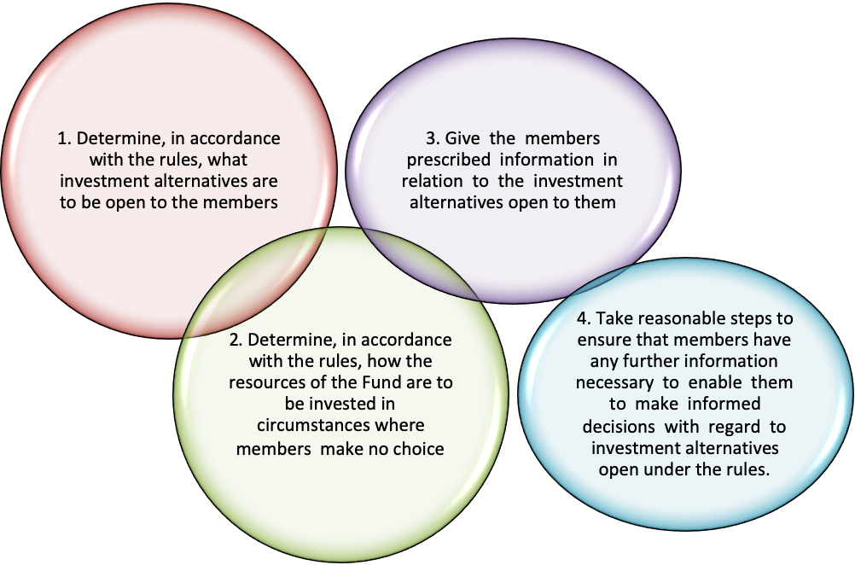

Trustees should aim for a range of investment options that will not overwhelm members and should act prudently in selecting investment options which are to be made available to fund members.
Trustees should not give members advice which they are not qualified to give. However, sufficient information should be given to allow an appropriate choice to be made.
Some practical steps Trustees can take to ensure that members exercise their investment choices properly.
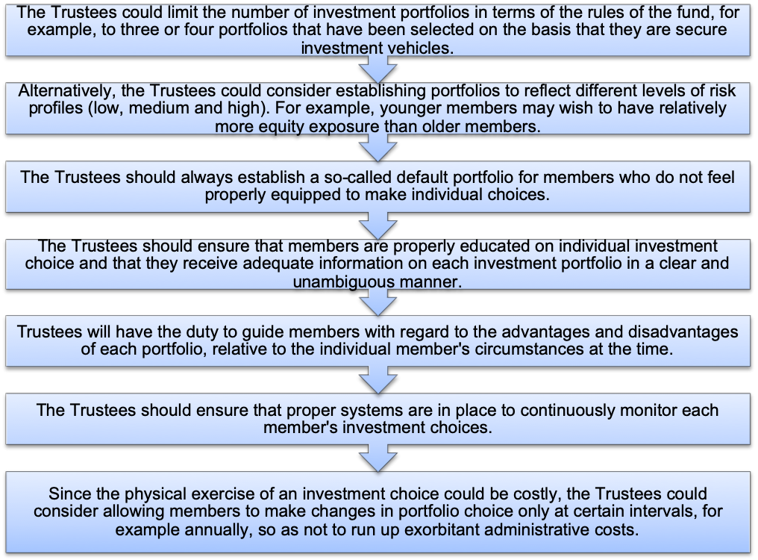

The potential liability for the Trustees if the members suffer losses as a result of their poor investment choices could be serious. If the Trustees themselves offer financial investment advice to the members, they will be judged according to the standard expected of a Trustee who is equipped with that knowledge and skill, i.e. as a reasonable investment expert. However, should it subsequently be found that the Trustees never had the requisite knowledge and skill to give investment advice, or if the investment advice that they gave turns out to be incorrect, the Trustees may be held liable for negligence.
It would, therefore, be prudent for the Trustees to employ the services of investment experts to educate members on individual investment choice.

5.12 Appointing an investment manager
Where the fund employs the services of an investment manager to manage the investment of fund assets, it would be a breach of fiduciary duty for the Board of Trustees to appoint a company/person without satisfying itself that such company/person is properly qualified.
The selection of the investment manager is one of the most critical decisions that the Trustee has to make as it will determine if the fund will meet its objectives in the long-term.
The process of identifying suitable investment managers starts with a simple statistical analysis wherein a survey is conducted on the different managers depending on the portfolio the fund wants to consider. The process does not only aim at identifying the historical best investment managers (e.g. traditional rating) but also competent investment managers in different market conditions to ensure that the fund can survive the different economic cycles.
The Trustees should, when selecting or appointing an investment manager, consider the following critical factors:
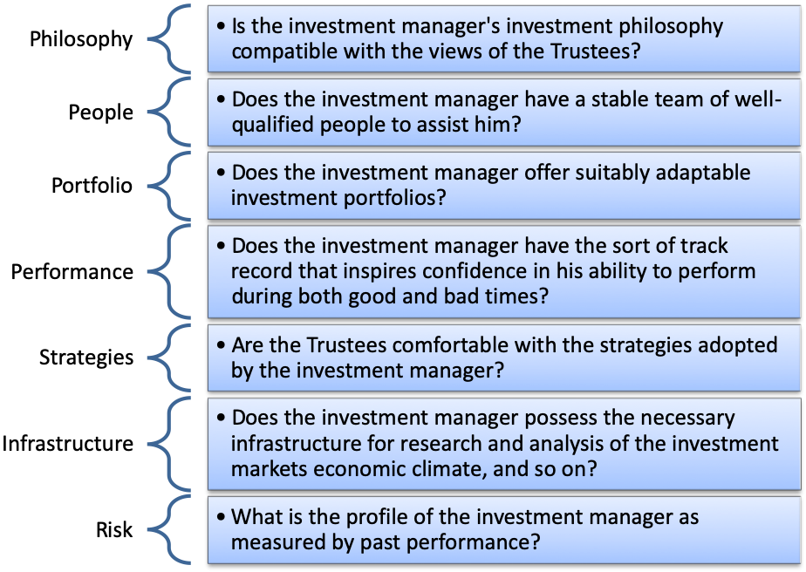
All these factors should be considered carefully when choosing an investment manager, and similar considerations apply when the Trustees appoint any other experts such as auditors and valuators.
While above-average past performance is not necessarily indicative of continuing good returns, there is little doubt that consistently good medium-term performance does give some indication of the investment manager's ability. However, returns should not be judged in isolation; all the various pertinent factors, circumstances, risk exposure, and so on, should be taken into account.
When assessing the appropriateness of fund investments and the investment manager's performance, the Trustees should seek independent advice to be able to evaluate such matters objectively. Independent surveys could also assist in this regard.
The Trustees cannot simply sit back and leave the investment of the fund's assets to the Asset Manager alone, but must actively acquaint themselves with the investment manager's actions and monitor them to ensure that reasonable care and attention is being exercised. Trustees must take an active interest in the investment of the fund's assets.

5.13 Monitoring fund investment performance
The Trustees should monitor the performance of their appointed investment manager or of their fund where they are managing the performance of the assets themselves. Even if members’ contributions and benefit levels are defined, and the employer has consistently met the contribution rates recommended by the actuary, the overall investment return is still relevant to the members of a Defined Benefit fund. There can be little doubt that good investment performance enhances the security of pension promises, while bad performance weakens that security.
Under a Defined Contribution fund, members’ benefits will be directly determined by the returns earned on the contributions paid.
It is, therefore, vitally important that Trustees know that their fund is maximizing its investment return within the objectives set. The normal measure of the investment performance of a fund is the benchmark set by the Board of Trustees. A comparison with other Retirement Funds of a broadly similar nature can also be done and this is usually done through participation in a performance measurement service.
Trustees should, with the help of their advisers, seek relevant comparisons of the performance of the manager relative to that of other managers operating similar funds.
Following the appointment of an investment manager the Trustees should meet with the manager as required, but at least twice a year. The manager’s performance should be monitored on an on-going basis having regard to the objectives set. Such monitoring should include not only the actual investment return achieved by the manager but also the investment strategy which was pursued on behalf of the fund. The Trustees should ask the manager to explain any aspect of the fund investments which they do not understand.

5.14 How do you measure investment performance?
Traditionally investment surveys concentrated on nominal returns, i.e. actual returns achieved by participants. There is, however, increasing recognition that it is just as important to measure the risk or volatility inherent in achieving the returns.
Investment return is in itself, quite meaningless. One needs to judge an investment return, given the level of risk taken to achieve that return.
The trustees and the Investment Consultants should agree on the benchmarks that will be used to measure performance. Examples would be;
- Long term benchmark based on the long term Consumer Price Inflation (CPI). E.g. CPI +5% over a rolling five year period as the benchmark.
- The passive benchmark based on the weighted allocation of the underlying managers’ benchmarks.
- For the underlying asset classes, the following indices can be used as benchmarks:
Asset Class | Index
Equities | FTSE JSE All Share/SWIX
Bonds | BEASSA All Bond Index
Cash | STEFI Composite Index
Property | FTSE/JSE SAPY Index
Foreign Assets: Equity | MSCI World Equity Index
Foreign Assets: Bonds | Barclays Capital Global Aggregate

5.15 How do you measure risk?
The measure commonly used for risk is the standard deviation of the monthly returns. This measures the extent to which the returns over several years vary.
A high standard deviation reflects high volatility or risk and conversely, a low standard deviation would reflect low risk.
There are other measures of risk and reward, like return per unit of risk. This unitizes the risk and attaches a return to it. In this case the higher the return per unit of risk, the better.
These are commonly used measures. Of course, there are many sophisticated mathematical and statistical measures of the various components, but suffice to say that risk and return have a strong correlation and that the one needs to be viewed in terms of the other.

5.16 Investment management agreement
An Investment Management Agreement formalizes the relationship between Trustees and their investment manager and complies with the general requirement of prudence.
An Investment Management Agreement also regulates the liability of the investment manager to the fund and therefore any exemption clause contained in the agreement should be considered by the Trustees with particular care.

5.17 Investment Manager Termination
The decision to terminate an investment manager’s appointment should not be taken lightly. Trustees should avoid judging performance on a short term basis. However, Trustees also need to be prudent to avoid remaining with a manager who is no longer delivering value.
The appointment should be reviewed or terminated if in the opinion of the Trustees:
  - The investment manager does not meet the agreed investment objective within the agreed time frame.
  - Poor investment performance over extended periods compared to peers.
  - There is a significant change in the team managing the assets such as the departure of key investment decision-makers on the portfolio or overall management.
  - There is a significant change in the shareholders of the company.
  - There is a change in the manager’s investment philosophy or process and such change are no longer compatible with the views of the Board.
  - There is a significant change in the business operations, affecting the manager’s financial viability
  - There is regulatory non-compliance.
  - The conditions of the mandate agreement are not adhered to.
  - The Fund’s investment strategy changes.
Any decision to change investment managers should, however, be quite categorical and take all relevant factors into account. The period under consideration must be significant, not short term only.
The reason for stressing this is that performance measurement over short time horizons and the results thereof are often of little value or relevance to the determination of the performance of, and the achievement of the aims of a long-term retirement fund. Short-term analysis of the investment manager's performance may even be detrimental to the long-term interest of the fund if it prejudices the implementation of an appropriate long-term strategy.

5.18 Socially Responsible Investing
Socially responsible investing (SRI), also known as sustainable, socially conscious, "green" or ethical investing, is any investment strategy that seeks to consider both financial return and social good.
In general, socially responsible investors encourage corporate practices that promote environmental stewardship, consumer protection, human rights, and diversity. Some funds avoid businesses involved in alcohol, tobacco, fast food, gambling, pornography, weapons, undemocratic governments, and/or the military equipment suppliers to war zones.
The above concerns are sometimes summarized under the heading of ESG issues: environment, social justice, and corporate governance.
Environmental: | This includes the topics of Sustainability, Ecosystems, Climate Change and Fossil Fuels versus Renewable Energy.
Social: | Socio-economic impact, Diversity, Human Rights, Consumer Protection, Animal and human welfare can be categorised here.
Governance: | Management structures, employee relations, and ethics are included in this category. The King Reports cover corporate governance.

"Socially responsible investing" is one of several related concepts and approaches which influence and, in some cases govern, how asset managers construct portfolios and, where applicable, Trustees must ensure that asset managers abide by these principles.
The term "socially responsible investing" sometimes refers to practices that seek to avoid harm by screening companies included in an investment portfolio. However, the term is also used more broadly to include more proactive practices such as impact investing, shareholder advocacy, and community investing.
In 2006, the United Nations Environment Programme, led by the then UN Secretary-General, Kofi Annan launched its Principles for Responsible Investment which provides a framework for investors to incorporate environmental, social, and governance (ESG) factors into the investment process.
The United Nations-supported Principles for Responsible Investment (PRI) Initiative is an international network of investors working together to put the six Principles for Responsible Investment into practice. Its goal is to understand the implications of sustainability for investors and support signatories to incorporate these issues into their investment decision making and ownership practices. In implementing the principles, signatories contribute to the development of a more sustainable global financial system.
The principles are voluntary and aspirational, therefore not prescriptive. They offer a menu of possible actions for incorporating environmental, social, and corporate governance (ESG) issues into investment practices across asset classes.
As of December 2014, over 1300 signatories representing US$45 trillion assets under management had signed up to the principles. In some cases, before retaining an investment manager, Trustees will inquire as to whether the manager is a signatory to the United Nations-supported PRI.
The Principles are based on the notion that ESG issues, such as climate change and human rights, can affect the performance of investment portfolios and should, therefore, be considered alongside more traditional financial factors if investors are to properly fulfill their fiduciary duty.
The six Principles provide a global framework for mainstream investors to consider these ESG issues.

The principles
Principle 1. Incorporate ESG issues into investment analysis and decision-making processes | - Address ESG issues in investment policy statements  - Support development of ESG-related tools, metrics, and analyses  - Assess the capabilities of internal investment managers to incorporate ESG issues  - Assess the capabilities of external investment managers to incorporate ESG issues  - Ask investment service providers (such as financial analysts, consultants, brokers, research firms or rating companies) to integrate ESG factors into evolving research and analysis  - Encourage academic and other research on this theme
Principle 2. Be active owners and incorporate ESG issues into ownership policies and practices | - Develop and disclose an active ownership policy consistent with the principles  - Exercise voting rights or monitor compliance with voting policy (if outsourced)  - Develop an engagement capability (either directly or through outsourcing)  - Participate in the development of policy, regulation, and standard-setting (such as promoting and protecting shareholder rights)  - File shareholder resolutions consistent with long-term ESG considerations  - Engage with companies on ESG issues  - Participate in collaborative engagement initiatives  - Ask investment managers to undertake and report on ESG-related engagement
Principle 3. Seek appropriate disclosure on ESG issues by the entities in which they invest | - Ask for standardized reporting on ESG issues (using tools such as the Global Reporting Initiative)  - Ask for ESG issues to be integrated within annual financial reports  - Ask for information from companies regarding adoption/adherence to relevant norms, standards, codes of conduct or international initiatives (such as the UN Global Compact)  - Support shareholder initiatives and resolutions promoting ESG disclosure
Principle 4. Promote acceptance and implementation of the principles within the investment industry | Include Principles-related requirements in requests for proposals (RFPs)  - Align investment mandates, monitoring procedures, performance indicators, and incentive structures accordingly (for example, ensure investment management processes reflect long-term time horizons when appropriate)  - Communicate ESG expectations to investment services providers  - Revisit relationships with service providers that fail to meet ESG expectations  - Support the development of tools for ESG integration  - Support regulatory or policy developments that enable implementation of the principles
Principle 5. Work together to enhance their effectiveness in implementing the principles | - Support/participate in networks and information platforms to share tools, pool resources, and make sure of investor reporting as a source of learning  - Collectively address relevant emerging issues  - Develop or support appropriate collaborative initiatives
Principle 6. Report on their activities and progress towards implementing the principles | - Disclose how ESG issues are integrated within investment practices  - Disclose active ownership activities (voting, engagement, and/or policy dialogue)  - Disclose what is required from service providers about the principles  - Communicate with beneficiaries about ESG issues and the principles  - Report on progress and/or achievements relating to the principles using a ”Comply or Explain‟ approach  - Seek to determine the impact of the principles  - Make use of reporting to raise awareness among a broader group of stakeholders

The Code for Responsible Investing in South Africa (CRISA)
The Code for Responsible Investing in South Africa (CRISA) gives guidance on how the institutional investor (Retirement Fund) should execute investment analysis and investment activities and exercise rights to promote sound governance.
There are five key principles:
Principle 1 – An institutional investor should incorporate sustainability considerations, including ESG, into its investment analysis and investment activities as part of the delivery of superior risk-adjusted returns to the ultimate beneficiaries. | The Code requires institutional investors to develop policies on how they incorporate sustainability considerations, including ESG, into investment analysis and activities. Institutional investors should ensure that this policy is implemented and establish processes to monitor compliance with the policy.
Principle 2 – An institutional investor should demonstrate its acceptance of ownership responsibilities in its investment arrangements and investment activities. | The second principle requires institutional investors to demonstrate a responsible approach to shareholding by, among others, implementing a policy detailing mechanisms of intervention and engagement with companies when concerns have been identified, as well as the means of escalation if concerns raised cannot be resolved. The Code requires such a policy to also detail the approach to voting at shareholder meetings, including the criteria to be used in reaching voting decisions and public disclosure of full voting records. Controls should also be introduced by the institutional investor to prevent insider trading as defined by the Security Services Act.
Principle 3 – Where appropriate, institutional investors should consider a collaborative approach to promote acceptance and implementation of the principles of CRISA and other codes and standards applicable to institutional investors. | Institutional investors are encouraged to work with other shareholders, service providers, regulators, investee companies, and ultimate beneficiaries to promote CRISA and sound governance.
Principle 4 – An institutional investor should recognise the circumstances and relationships that hold a potential for conflicts of interest and should pro-actively manage these when they occur. | Institutional investors are encouraged to develop a policy on the prevention and management of conflicts of interest and establish processes to monitor compliance with this policy.
Principle 5 – Institutional investors should be transparent about the content of their policies, how the policies are implemented, and how CRISA is applied to enable stakeholders to make informed assessments. | The Code requires institutional investors to disclose to stakeholders at least once a year fully and publicly to what extent the Code has been applied.  If an institutional investor has not fully applied one of the Principles of the Code, the reasons should be disclosed. Disclosure as well as policies should be made public.  Institutional investor and their service providers should also, before agreeing to a proxy or other instruction to keep voting records confidential, carefully consider the reasons put forward to justify confidentiality.

5.19 The Impact of recent economic developments on investments
5.19.1 COVID – 19 Effects on Retirement Funds
The COVID-19 virus and the subsequent global lockdowns have had far-reaching implications for all walks of life world-wide, and the Retirement Fund industry was also massively impacted. As at the end of March 2020, the Johannesburg Stock Exchange had lost about 25% of its value.
Investment markets were severely impacted leading to negative investment returns on fund investments only comparable to the 2008 financial crisis.
There have been developments in the retirement fund space during the lockdown which are important for members to note;
- “Pension fund administration” has been specifically included as an Essential Service in terms of the Regulations issued in terms of the Disaster Management Act, 2002.
The FSCA (the retirement fund regulator) also issued two communications on COVID-19:
- FSCA Communication 11 of 2020 – Employers facing financial distress are afforded relief in respect of the payment of contributions provided rules are amended and approved by the FSCA.
- FSCA Communication 12 of 2020 –Boards of trustees are encouraged to “clearly communicate COVID-19 developments and risk management strategies to fund members, to promote calm and minimise the risk of premature fund withdrawals”.
5.19.2 South Africa’s Credit rating downgraded to junk status
On 26 March 2020, rating agency company Moody’s cut South Africa's credit rating to sub-investment grade from BAA3 to BA1 with a negative outlook. South African banks were also subsequently downgraded.
Foreign Pension Funds will now unfortunately not be able to invest in South African bonds due to the risk associated with the downgrade. The downgrade means the Government will be saddled with higher borrowing costs that will, in turn, increase the cost of funding for vital social services such as health and education.
What is the impact of the downgrade?
- Higher borrowing costs for the government will crowd out spending on much-needed social, infrastructure, and economic programmes.
- A knock to business sentiment leading to reduced foreign direct investment and also lower local investment resulting in weaker growth and increased pressure on employment.
- A more depreciated currency leads to a higher cost of imported goods, which could raise inflation.

Chapter 6

Retirement Fund Benefits
Good knowledge of this chapter will ensure competency in the following specific outcomes:
- Discuss the different benefits offered by retirement funds
- Explain the income replacement ratio
- Describe the different annuity options available on the market
- Explain the difference between approved and unapproved risk benefits
- Discuss the provisions of section 37C in distributing death benefits
- Outline the factors that should be considered when distributing death benefits.

BACKGROUND: The Act specifies that the Trustees shall make arrangements for the payment of the benefits as provided for under the rules of the fund as they become due.
The task of paying the benefits will usually be delegated by the Trustees to a fund administrator, the written terms of whose appointment should show clearly what functions are to be exercised by it and should set out any limitations on its powers. Matters requiring referral to the Trustees should be specified as well as arrangements for periodic reports to be made to them on how the arrangements for payment of benefits are conducted on their behalf. The fund administrator’s report should be reviewed at every Trustee meeting.

6.1 Retirement Benefits
These include retirement pensions and/or lump sums payable to members. The benefits arising under a Retirement Fund will be set out in the rules.
Retirement benefits may be payable on:
- Normal retirement,
- Early retirement (including ill-health or retrenchment) or
- Late retirement.
Retirement benefits must be dealt with following the fund’s rules and in compliance with the tax laws.
A key concern to people retiring is whether the amount saved for retirement will be adequate to maintain their lifestyle in retirement. There are two critical components members should be aware of:
6.1.1 Income Replacement ratio - A Replacement Ratio is a person’s gross income after retirement, divided by his or her gross income before retirement. For example, assume someone earns R200, 000 per year before retirement. Further, assume he or she retires and receives R150, 000 of retirement income. This person’s replacement ratio is 75 percent (150,000 / 200,000).
The replacement ratio is what members need to maintain their pre-retirement standard of living after retirement. Generally, a person needs less gross income after retiring, primarily due to four factors:
- Income taxes go down after retirement. This is because extra deductions are available for those over age 65, and taxable income usually decreases at retirement.
- Certain retirement benefits are partially or fully tax-free. This reduces taxable income and, therefore, the amount of income needed to pay taxes.
- Saving for retirement is no longer needed.
- Changes in age- and work-related expenditures that occur at retirement also influence the amount of income someone needs at retirement. The expectation is that the member no longer has debts or daily transport costs to pay, or school fees to worry about.
6.1.2 The power of compound interest
The best way to ensure adequate retirement income is to start saving early. “The amount of capital you start with is not nearly as important as getting started early,” writes Burton Malkiel in The Random Walk Guide to Investing. “Procrastination is the natural assassin of opportunity. Every year you put off investing makes your ultimate retirement goals more difficult to achieve.”
For example, if 20-year-old Nomfundo contributes R920 monthly to the retirement fund for 35 years, and leaves the money to earn an average 12% return, the retirement savings will total over R6 million, but waiting 10 years to begin saving will require R1,700 per month to achieve the same objective, whereas waiting for the last 10 years to being saving will require R25,820 per month
The cost of waiting
To make compounding work for our members, encourage them to:
- Start early - The younger you start, the more time compounding has to work in your favour, and the better your retirement income.
- Maximize contributions - Remain disciplined, and make saving for retirement a priority. Do whatever it takes to maximize your contributions.
- Be patient and Preserve - Do not touch the money. Compounding works only if you allow your investment to grow. The results will seem slow at first but persevere. Most of the magic of compounding returns comes at the very end.
Compounding creates a snowball of money. At first, the returns may seem small, but with time, they will become enormous.
When one retires, the main concern is to protect your lifestyle in retirement and ensure that the income available can be stretched for as long as possible bearing in mind no one knows for how long it will be needed.
Two risks that a member faces are:
- The possibility that you live too long and run out of money (longevity risk)
- The possibility that the income you receive cannot keep pace with your living expenses (inflation risk).
It is therefore imperative that professional advice is sought. Trustees should assist members by pointing them in the right direction.
Most funds will assist their members by arranging for the following;
- Pre-retirement counselling (Member information sessions for those close to retirement)
- Provide default options for those who do not make a choice.
At retirement, the member has to make the following two critical decisions:
- How much of the savings should be taken as cash (Cash Commutation)?
- What type of annuity should be purchased, and from where?
6.1.3 Types of annuities
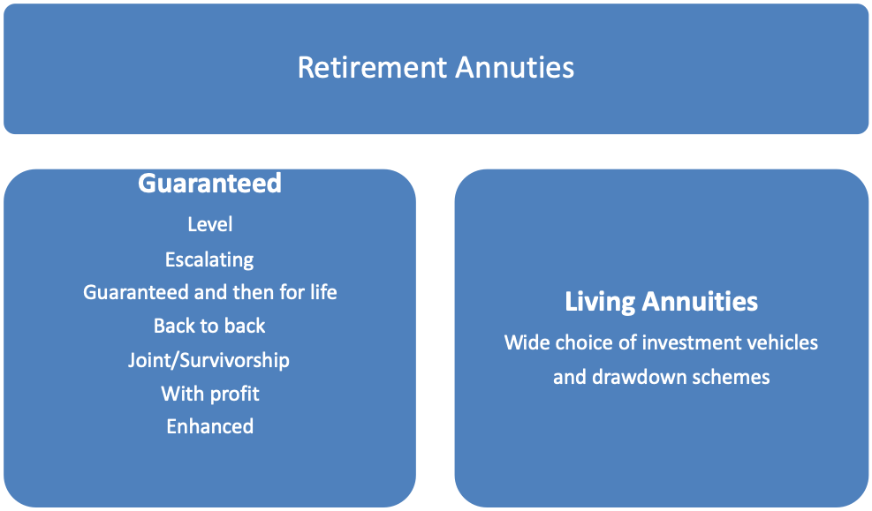

Guaranteed annuities
- Level guaranteed life annuity
This is a “traditional” type of annuity. A life insurer takes a lump sum payment at the date of retirement in exchange for regular level monthly payments made to the life insured. Payments are guaranteed for the life of the pensioner.
The advantage of this annuity type is that no matter how long the pensioner lives the monthly income is guaranteed. The investment and longevity risk are transferred to the insurer.
The obvious disadvantage to the member is that the income level does not increase. In technical terms, there is an inflation risk, which is borne by the member. Because the pension is non-increasing (level), but the cost of living is continually increasing, the net effect is a reducing purchasing power of the level pension.
This is especially a big concern in economies where inflation is high but not as much a concern where inflation is modest.
Also, there are no benefits for surviving dependents after the death of the pensioner.
- Escalating guaranteed life annuity
This is similar to the one above only difference being that it is designed to address the increasing costs of living along the way. Again, the insurer will take a lump-sum premium at the date of retirement, and in return, it will pay monthly pension amounts. The pension amounts will however increase each year.
There are several ways in which the pension can increase.
- The percentage level of increase can be fixed, e.g. 5% per annum. But what if inflation far outstrips this level?
- It can increase in line with some index of inflation, such as the Consumer Price Index (CPI).
- It can be a function of the inflation index, for example, CPI up to a maximum of 6% per annum.
The escalating annuity protects the pensioner’s income against the adverse effects of rising prices, but this comes at a cost! The insurer now picks up the inflation risk and therefore has to set aside more money to ensure they can deliver on the inflation promise. So an annuity that guarantees 100% of inflation increases will be more expensive to purchase.
As a result of the fact that there will be future increases and these have to be guaranteed, the initial starting pension is much lower. But in time the pension will increase above the starting fixed pension amount.
- With-profit life annuity
This is another form of increasing annuity. It is, however, not quite so straight forward! Under a with-profit arrangement, the annual increases are linked to the performance of the underlying investments, and not to an inflation index.
This means when the underlying investments increase in value, one can expect the above-inflation pension increases, but when they stay the same or decrease in value, the annuity increase could lag behind inflation.
However, over time, a with-profit annuity is likely to increase at a rate better than inflation, because a proportion of the underlying assets of the investment portfolio are invested in asset classes that typically provide returns that are well ahead of inflation.
So yet again, there is a trade-off; you give up the guaranteed link with inflation for a possibility of better long-term returns, but with the added risk that in some years, inflation might be higher than the increases on your pension.
- Back-to-back guaranteed life annuity
This type of policy has two parts – a life annuity, as well as life assurance. The member receives a monthly pension, but now part of the monthly pension income goes towards paying for the life insurance premium – which means that the insurer retains part of the monthly pension and pays out a smaller amount each month. The pension is payable for the life of the insured.
The difference between this and a traditional annuity is at the time of death. Single life annuity payments cease on the death of the member. With the back-to-back life annuity, there is a lump sum death benefit payable. Of course, there will be a trade-off – the higher the death cover, the higher the monthly cost of cover, and the lower the actual pension payments will be.
- Enhanced life annuity
As mentioned before, the cost of an annuity will depend on a host of assumptions, one of them being how long the pensioner is expected to live.
The longer the life expectancy, the more payments the insurer will have to make, and therefore the higher the total cost to the insurer. And, of course, the reverse is also true – if the person applying for a pension is in poor health, then it is safe to assume that he will not live as long as his healthy counterparts, and so there will be fewer annuity payments, driving the cost down.
So a person who can prove they are in poor health, can get a higher monthly pension.
There are, however, several other features that can be added to all of the above-mentioned annuity types, and these are listed below.
- Joint and Survivorship life annuity
The annuity types considered above typically focus on the member-only. However, some members would want to guarantee an income for their spouse.
The Joint and Survivorship arrangement ensures that the last surviving member of a couple will have a pension for life. The focal feature of these is what is called a reversionary percentage – which is how much of the original pension payable to Mr. Dlamini would Mrs. Dlamini get after his death? The usual reversionary percentages are 50%, 75%, or 100%, but it could be anything, provided it is specified up-front when purchasing the contract.
Spouse’s reversions can be attached to a level, escalating, or inflation-linked annuity arrangements.
Of course, the spouse’s reversion will carry a cost. This cost will depend on several factors which are used to determine the expected payment period or the level of the payment:
- Gender of the main annuitant – for example, women tend to live longer than men, so adding a female spouse onto the policy means that the insurer, in most likelihood, will have to make a greater number of payments, pushing the cost of the policy up.
- The age difference between the spouses – the younger the spouse, the longer he or she will live, again driving up the number of payments and therefore the cost.
- The reversionary percentage – the higher the reversion, the higher the cost.
- Guaranteed then for life annuity
A guarantee period is a common feature of most life annuities. A guarantee period would need to be specified at the time of retirement. Let us say that the chosen guarantee period is 10 years. What this means is that the pension will be paid for those 10 years at its full amount per month, whether or not the pensioner is alive. This is to ensure the member benefits meaningful from the lump-sum invested in purchasing the pension.
If the member lives beyond the guarantee period, then payments will continue for the rest of the member’s life.
If, however, the pensioner dies before the guarantee period is over, the pension will continue to be paid, at 100% of its level, until the end of the guarantee period. If the pensioner has beneficiaries or dependants, this pension will be paid to them. If there are no dependents, the pension will be paid into the estate.
If the pension arrangement had a spouse’s reversion option as well, then the spouse will receive 100% of the pension until the end of the guarantee period, and only after the guarantee period has expired, will the pension reduce to the pre-specified reversionary percentage (e.g., 50%).
Living annuities
This is a relatively new type of annuity. It is also known as an investment-linked living annuity. Under this arrangement, the payments are not guaranteed. There is no insurance contract, but rather a pure investment contract.
The Fund Credit from the retirement fund is invested with the insurer in a portfolio chosen by the pensioner.
The investment earns a return on the assets – be it positive or negative in line with the performance of the investment vehicle chosen. This means that the pensioner takes on the investment risk. This is the distinguishing factor between guaranteed and living annuities. Under guaranteed annuity arrangements, the investment risk is passed onto the insurer.
The pensioner “draws down” on the investments by taking a small chunk each month as a pension. The amount of draw-down allowed is limited to between 2.5% and 17.5% of the value of capital invested, per annum.
Risks Facing Retirees
Employment Risk | Many retirees plan to supplement their income by working either part-time or full time during retirement. Employment prospects among retirees will vary greatly because of demands for different skills and may change with health, family, or economic conditions.  Choosing the point at which you want to retire is integral to retirement planning. Retiring later is an alternative to increasing saving, but there is no certainty that appropriate employment will remain available. Working part-time is an alternative to full-time employment, and part-time jobs may be easier to obtain.
Longevity Risk | Running out of money before they die is one of the primary concerns of most retirees. Longevity risk is an even larger concern today, as life expectancy has risen. The life expectancy age at retirement is just an average age, with about half of retirees living past that age and a few living past age 100. Planning for enough income to live only to your life expectancy age will be adequate for about half of retirees.
Death of a Spouse | Grief over a spouse’s death or terminal illness contributes to high rates of depression and suicide among the elderly.  Financial vehicles are available to protect the income and needs of survivors after the death of a partner or spouse, such as life insurance, survivors’ pensions, and long-term care insurance. Estate planning is also an important aspect of providing for survivors.
Change in Marital Status | Divorce or the separation of a cohabiting couple can create major financial problems for both parties.
Healthcare and Housing Risks | Unexpected medical bills  These are a major concern for many retirees. Prescription drugs are a major issue, especially for the chronically ill. Older people usually have greater healthcare needs and may require frequent treatment for several different health-related issues.
Financial Risks | Inflation risk  Inflation should be an ongoing concern for anyone living on a fixed income. Even low rates of inflation can seriously erode the well-being of retirees who live for many years. A period of unexpectedly high inflation can be devastating.  Interest rate risk  Lower interest rates reduce retirement income by lowering growth rates for savings accounts and assets. As a result, individuals may need to save more to accumulate adequate retirement funds. Annuities yield less income when long-term interest rates at the time of purchase are low. Low real interest rates will also cause purchasing power to erode more quickly.  Lower interest rates can reduce retirement income and can be particularly risky when people are depending on drawdown from savings to finance their retirement. On the other hand, a problem also exists if interest rates rise, causing the market value of bonds to drop.  Increases in interest rates can also negatively impact the stock market and the housing market, thereby affecting the retiree’s disposable income. All the same, because of their effect on savings income, high real interest rates, over and above rates of inflation, can make retirement more affordable.  Stock market risk  Stock market losses can seriously reduce retirement savings. Common stocks have substantially outperformed other investments over time and thus are usually recommended for retirees as part of a balanced asset allocation strategy. However, the rate of return that you earn from your stock portfolio can be significantly lower than the long-term trends. Stock market losses can seriously reduce one’s retirement savings if the market value of your portfolio falls.  The sequence of good and poor stock market returns can also impact your retirement savings amount, regardless of long-term rates of return. A retiree who experiences poor market returns in the first couple of years in retirement, for example, will have a different outcome than a retiree who experiences good market returns in the first couple of years of retirement, even though the long-term rates of return might be similar. Early losses can mean less income during retirement. Later losses can have a less-negative impact, because an individual may have a much shorter period over which the assets need to last.

6.2 Risk Benefits
There are essentially two types of risk benefits: approved and unapproved. An approved risk-benefit is a contract between the retirement fund and the insurer. An unapproved benefit is a contract between the employer (or the employees as a group) and the insurer.
Please note that “unapproved” cover simply means that it is not offered under a tax approved retirement fund and therefore not covered under the provisions of the Pension Fund Act.
The differences between approved and the unapproved cover are summarized below:
 | Approved cover | Unapproved cover
Contract | With Fund | With Employer
Fund Rules | Cover provided in the Rules of the Fund | Not in terms of the Fund Rules
Contribution/ premium | Taxed as a fringe benefit in the member’s hands and then deemed to have been contributed by the employee. Employer contributions together with member contributions are tax-deductible by the member, subject to a maximum of 27.5% of the greater of the member’s remuneration or taxable income (subject to an annual cap of R350 000).  Tax-deductible for the employer. | Taxed as a fringe benefit in the employee’s hands.  It is not tax-deductible for the employee.  Tax-deductible for the employer.
Taxation of lump sum death benefits | R0 - R500 000: 0%  R 500 001 - R 700 000: 18%  R 700 001 - R 1 050 000: R36 000 + 27% of amount above R700 000  R 1 050 001 and above: R130 500 + 36% of amount above R1 050 000  It must be noted that any amounts received on previous withdrawals (from a retirement fund) will be taken into account when applying the above tax table, i.e. it is cumulative.  Not subject to estate duty. | Disability, funeral, and severe illness cover are paid tax-free to the member directly.  Death lump sum benefit is tax-free.  Unapproved death lump sum benefits are subject to estate duty.  Any benefit accruing to a surviving spouse will qualify for a section 4(q) deduction which means that the benefit amount will be deducted before the final estate duty liability is determined.
Payment of death benefits | Benefits are paid in terms of Section 37C, as deemed equitable by the board of trustees of the fund. | The payment of benefits is not subject to Section 37C.  Benefits are paid to nominees/estate  Members nominate who will benefit from the cover and no one has the power to change that.
Disability benefits | Permanent disability can be provided under a retirement fund and is treated as a retirement benefit. | Temporary disability cover (PHI) always regarded as an unapproved benefit.

Since 1 March 2015 the tax treatment of premiums to a temporary disability (PHI) policy and premiums to unapproved group life insurance is the same, namely:
- If the terms of the employment contract compel the employer to pay the premiums, these must be taxed in the hands of the employee as a fringe benefit;
- If the terms of the employment contract compel the employee to pay the premiums, these must be taxed in the hands of the employee and must be deducted from the after-tax salary of the employee;
- There is no tax deduction for employees in respect of premiums to a PHI policy, but from
1 March 2015, PHI benefits are no longer taxable.

Comparison
Feature | Approved | Unapproved
Premium | Taxable as part of fund contributions | Taxable in member’s hands
Tax deduction of contribution | Yes. Part of 27,5% / R350 000 limit | No
Impact on maximising retirement savings in the fund | Yes. Reduces amount of contribution which can be allocated towards savings | No
Benefit | Taxable on retirement tax table | No tax
Salary payback available | No | Yes
Ability to postpone payment of benefit at retirement | No | Yes, via a cover continuation option.

Risk-benefit premiums
The premium rates for group life insurance and disability benefits are normally payable monthly in advance to provide cover during that month.
If premiums are not paid on time, usually a grace period of 15 days is allowed, after which cover may be discontinued.

6.3 Death Benefits
Benefits are generally payable by Retirement Funds on the death of a member in service. The benefits payable will be set out in the rules. Death in service benefits in most Funds take the form of a lump sum (multiple of annual salary) but many funds also pay monthly pension benefits to dependants and other beneficiaries, for varying periods of time.
Death benefits can also be provided under a separate Group Life Assurance Fund.
Death benefits are subject to a medical free cover limit and whether or not the member underwent the necessary medicals
What is Medical Free Limit?
The Medical Free Limit is the amount of cover granted by an Insurer of a fund, or the fund itself if self-insured, below which, no medical examinations or other evidence of health will be required.
It is expensive to have all fund members be medically examined, thus it is not cost-effective to examine everyone, particularly those with low cover.
Within any group of people, some are medically sound and those who are not. An Insurer or fund will only wish to examine those people with high death and disability cover.
Medical free limits may sometimes be applied where there is a minimum number of members or a minimum total sum assured.
The medical free limit can be amended at any time, however, once a member’s cover in terms of the medical free limit available is granted, it cannot be taken away.
What happens if a member’s cover exceeds the Medical Free Limit?
The member will be asked for medical information or to undergo a medical examination to provide evidence of health to obtain cover above the Free Limit. Whilst waiting for this information the amount of cover will generally be the full cover in terms of the rules, but subject to any maximum amounts that the Insurer may impose.
6.3.1 Distribution of Death Benefits (Section 37C of the Act)
Section 37C of the Act expressly stipulates how the death benefit must be dealt with. As a result of the stipulation contained in section 37C of the Act, Trustees cannot deviate from the requirements of this section. The death benefits payable do not form part of the assets in the estate of the member and therefore are not dealt with by way of the WILL, but shall be dealt with as in this section.
The broad aim of section 37C is to provide for financial relief to the member's legal and factual financial dependants in a fair manner between all the member's dependants and/or nominated beneficiaries.
The Board has to investigate and identify all the legal and factual dependants of a deceased member. Nomination forms go a long way in assisting the Board in this regard.
The Board has twelve months from the death of the member, to identify and equitably distribute the benefits.
The Act defines dependants and has created three categories:
1) A legal dependant,
2) A factual dependant, and
3) A future dependant.
A cohabiting partner for example could qualify as a “factual dependant”. The person claiming to be a factual dependant will have to prove she was dependent on the deceased at the time of his death and Trustees should satisfy themselves regarding the level of dependency.
- Members may nominate beneficiaries, and these persons will be considered along with the other qualifying dependents.
6.3.2 Dependants
The fund rules will generally define what is meant by “dependants”. The definition would generally include the spouse, children (biological or adopted) of the member, nominees’ and beneficiaries. Trustees need to exercise some element of judgment in this regard in ensuring that benefits are paid in a form and in shares that reflect the needs of the dependants.

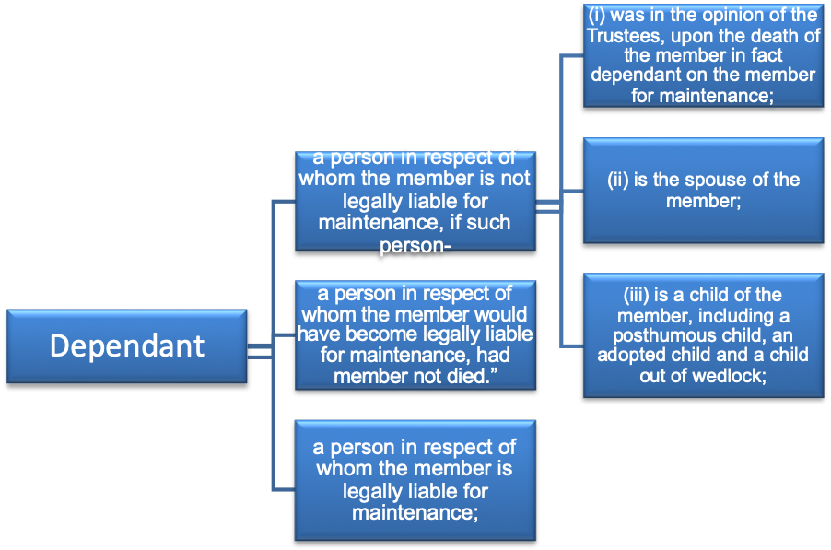
Types of Marriages recognized in terms of Section 37C
In terms of the Pension Funds Act section 37C, a spouse for a lump sum benefit is defined as a person who is the permanent life partner or spouse or civil union partner of a member following the Marriage Act, the Recognition of Customary Marriages Act, the Civil Union Act, or the tenets of a religion.
Civil Marriage (Marriage entered into in terms of the Marriage Act) | - marriages in community of property;  - marriages out of community of property without accrual; and  - Marriages out of community of property with accrual.
Customary marriage | Marriage conducted following traditional customs and culture of South Africa’s indigenous people as enshrined in the Recognition of Customary Marriages Act (“RCMA”),
Common-law marriage | Cohabitation, also referred to as a common-law marriage, living together or a domestic partnership is not recognised as a legal relationship by South African law.  A common-law partner may receive pension benefits as a factual dependant if he/she qualifies as such under the definition of ‘dependant’. A common-law partner will, however, not be entitled to their partner’s pension interest on termination of their relationship.
Civil Unions | The Civil Union Act incorporates same-sex partners and gives the same status to civil marriages as those recognised in terms of the Marriage Act
Tenets of a religion | Marriages under other religions not legally recognised in South Africa but involving South African citizens.

6.3.3 Trustee Discretion
When lump-sum death benefits are payable, the Trustees must use their discretion to decide on the distribution of these benefits. The discretionary power may be very wide indeed and may empower the Trustees to decide on payment to anyone or more of a very wide category of potential dependants or beneficiaries.
Once the discretionary power is exercised, provided that it is exercised in good faith and that the Trustees have done everything practicable to ascertain the facts and circumstances of potential claimants, the decision, if challenged, is unlikely to be overturned. The court or Adjudicator would most likely apply the “Prudent Person’s test”.
6.3.4 Investigations
Trustees are to conduct thorough investigations before distributing a death benefit. As part of the investigation process, Trustees are required to trace and identify all the dependants of the deceased member before allocating the death benefit.
There remains a chance that in the tracing process, Trustees may not become aware of a dependant of a deceased member and may, therefore “exclude” the dependant or nominee from the distribution process. If the dependant or nominee appears after the Trustees have distributed and paid the death benefit, the relevant question that will most certainly be asked is whether the Trustees took all reasonable steps to trace, before paying the death benefit.
There is no duty on the dependants to come forward and prove that they are dependants of the deceased member. The duty to investigate lies with the Trustees.
6.3.5 Allocation of Benefits
When determining how to apportion the available benefit between the various dependants and nominated beneficiaries, many factors must be taken into account.
The following factors are crucial in distributing the benefits:
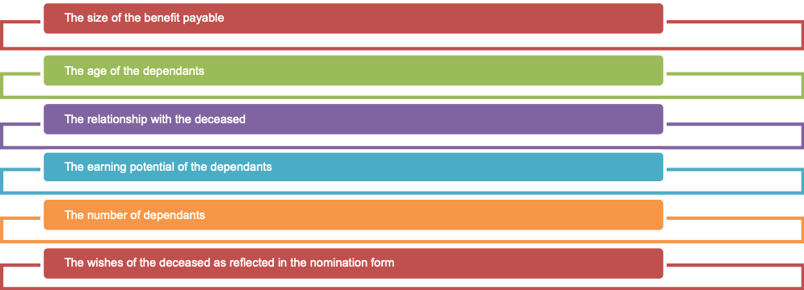
It would be quite in order, for example, especially where the benefit is not large, to decide that the full amount is to be paid to the deceased member's spouse and young minor children in his or her care while making no payment to major children (either in regular employment or able to find employment) or nominated beneficiaries. Disappointed beneficiaries, even if nominated by the deceased, who do not receive a benefit, have no claim against a Trustee, unless the Trustee has not made his decision in good faith or has not applied his mind to the matter.
6.3.6 “Nomination Forms”
Before paying out lump-sum death benefits, Trustees should also ascertain whether the deceased member completed a form of the nomination of dependants. Such a form cannot bind the Trustees but they would normally try to give effect to the deceased member’s wishes. They must not do so where the member’s wishes conflict with the provisions of the Rules of the fund and the law.
Trustees should carefully exercise any discretionary power connected with the payment of death benefits when the occasion arises. Trustees who have to exercise a discretionary power should be fully aware of the options open to them on the payment of death benefits and the persons or categories of persons covered by definitions such as “dependants”, “beneficiaries”, etc. Trustees should ensure that inquiries are made by them, or on their behalf, which will ascertain enough detail relating to beneficiaries to enable them to exercise discretionary powers.
6.3.7 Payment of Death Benefits to Beneficiary funds
A beneficiary fund is designed to accept and administer lump sum death benefits allocated to minor dependents by Trustees of deceased Fund members.
Beneficiary funds are cost-effective, tax-effective (payments out of a beneficiary fund, whether capital or income, is tax-free), are governed by professional Trustees, and offer institutional investment returns.
Beneficiary funds comply with the same regulatory and governance standards as any other retirement fund such as member communication policy, investment policy, code of conduct, and risk policy.
Upon the death of a Member, the Board has three duties;
- The first duty is to conduct a thorough investigation to identify the circle of potential beneficiaries i.e., dependants and nominees.
- The second duty is to decide on an equitable distribution of the benefits.
- The third duty is to effect an appropriate mode of payment of the benefit.

Beneficiary funds play an important social role as a mode of payment for Trustees to consider, particularly among blue-collar worker families where guardians may not be sufficiently financially knowledgeable to manage minors’ funds on their own or where minor children are not staying with biological parents and their interests may not be sufficiently protected.
The Board must note that the payment of the minor child's benefit to her/his legal guardian should be done in the ordinary course of events unless there are valid reasons for depriving the guardian of the duty to take charge of her/his minor child's financial affairs.
The Board must consider the following relevant factors in making this decision:
(a) the amount of the benefit;
(b) the ability of the guardian to administer the amounts of money;
(c) the qualification (or lack thereof) of the guardian to administer the amounts of money;
(d) the time frame until the minor attains the age of majority;
(e) the nature of the relationship between the guardian and the minor child.
(f) the best interests of the minor child

The following reasons are sufficient to deprive guardian or caregiver the right to administer death benefits on behalf of a minor beneficiary
- Insolvency,
- Mental disability, or
- Incapacity to manage his affairs.

6.4 Withdrawal Benefits
Withdrawal Benefits are payable to members on termination of employment before age 55, provided such termination of employment is not due to retrenchment, redundancy, or abolition of office. This could take the form of Resignation, Dismissal, and Termination of contract or if the member absconded.

Options on member portion;
- Cash benefit – members can withdraw cash subject to tax.
- Transfer benefit – members can transfer benefits to another registered fund especially where the member is joining another Retirement Fund or to a Preservation Fund.
- Leave it in a fund (Paid-up benefit).

6.5 Disability Benefits
Benefits of disability
All employees face the risk of being unable to earn an income during their lifetime due to injury or illness which sometimes might even threaten their employability in the long term.
While most employment contracts provide for sick leave up to 3 months in most cases, most disability cases can prolong beyond the three months and employers may not be in a position to continue paying a salary for an unproductive employee indefinitely.
Disability cover provides a solution to the above dilemma. The cover can either be for a temporary period or permanent disablement before retirement after the waiting period.
Waiting Period - The waiting period is the period that a client has to be partially or fully disabled to be able to claim a benefit. Some products will pay retrospectively from day 1 of illness, while others will only pay after the expiry of the waiting period.
The waiting period on the policy is critical as it has a direct impact on member’s cash-flow planning on becoming disabled before the onset of the disability benefit payment. It is important to synchronise the waiting period in the policy with the companies HR policy.
Generally, the longer the waiting period selected, the cheaper the premium will be for the income disability product.

6.5.1 Temporary disability Benefits (Permanent Health Insurance)
The income protection benefits provide indemnity for loss of income as the client will receive a monthly payment until retirement age. There are also income disability benefits that only provide payments for a limited period often 12 to 24 months.
Income protection benefits protect both temporary and permanent disability whereas the lump sum benefits, typically, only pay when a client is permanently disabled.
The tax treatment of the lump sum benefits and income protection benefits may also differ in respect to the tax-deductibility of premiums and the taxation of the benefit payments depending on whether they are approved or unapproved benefits.
Benefits are usually provided as a percentage of the member’s salary before disability, commonly 75% of salary but can be 100% for a limited period like 2 years in terms of the Association of Saving and Investments of South Africa (ASISA)’s code of good practice on disability insurance.
The fund rules would specify the definition of disability, which is usually linked to the member’s ability to perform in their current occupation. The definitions below are usually used;
Aspects to look out for in the policy
- Definition of disability - The most common disability definition types are:
Own occupation | This covers if the insured is unable to perform their particular occupation.
Own or any reasonable alternative occupation | This definition measures the ability of the insured to perform any occupation for which he/she is reasonably qualified, based on his/her training, education, or experience.
Any occupation | This definition measures the ability of the client to perform any occupation irrespective of his/her training, education, or experience.  This is the strictest definition as the client needs to be severely disabled to qualify under this definition.

Most funds would usually cover ‘own’ occupation definition for 2 years (24 months) and then to move to an ‘own or any reasonable occupation’ definition thereafter.
- Escalation of Disability Benefit – Most policies provide for increases in the benefits payable linked to CPI to enable benefits to keep pace with inflation, just like salary increases would whilst the member is working. Escalation is also important should a member die whilst on disability as the definition of salary whilst on disability could be compromised by the 75% provision and further no increases sometimes for a long period. Rules must be clear and consistent on such issues.
- Premium Waiver during disability - Most policies provide for a waiver of premiums payable by the Employer to the fund (at an extra premium to the insurer) to enable continued payment of fund contributions, group life insurance premiums, funeral benefits so that benefits are maintained without an additional cost to the employer. Usually set at the same level as employer contribution less disability premium as this will be waivered during the time member is receiving benefits.
- Actively at work clause - Most policies will provide cover for members who were actively at work at the inception of the policy. It is imperative though that when there is a change of underwriters, members on disability are identified and pre-existing conditions definitions do not impact benefits for those members in the future.
6.5.2 Permanent Disability Benefits
In an approved fund, once the member becomes totally and permanently disabled in terms of the policy and qualifies for the lump sum disability benefit, the lump sum disability insurance benefit, together with the member’s fund credit, becomes payable in terms of the rules of the fund. The member’s membership in the fund will then be terminated as the member’s employment will be terminated due to his disability. When a member is permanently disabled it is not expected that the client will recover and return to his occupation within the foreseeable future.
The permanent disability benefits lump sum in most instances is an acceleration of the group life benefit (multiple of salary), with the cover being gradually reduced as the member approaches retirement age typically cover will reduce by 20% per annum in the last 5 years.

6.6 Group Funeral Benefits
This cover is meant to assist in covering funeral costs. Most schemes provide cover for the entire family up until a child is a major or until after completion of formal studies. Benefits are usually paid within 48 hours of claim submission to ensure funds are available for the burial.

6.7 Home Loans
The Act allows pension funds to grant a loan to a member, or issue a guarantee so that the member may obtain a loan, to enable the member:
  - To purchase a dwelling, or to purchase land and erect a dwelling on it, for occupation by the member or a dependant of the member, provided the land shall be registered in the name of the member or his spouse;
  - To make additions or alterations to or to maintain or repair a dwelling which belongs to the member or his spouse and will be occupied by the member or a dependant of the member;
  - To erect a dwelling on land that the member or his spouse does not own but on which land the member or his spouse can exercise a right or privilege in terms of any customary or statutory law to build a dwelling for his occupation or occupation by his dependants;
It is therefore imperative that the Board puts in place governance mechanisms to ensure that the provisions of the Act are upheld.

Chapter 7

Fund Administration and Record-Keeping
Good knowledge of this chapter will ensure competency in the following specific outcomes:
- Explain the role of service level agreements in fund administration
- Discuss the different types of fund administration on the market
- Discuss the provisions of Section 13A in as far as payment of contributions is concerned
- Discuss the records that a fund has to keep
- Discuss the minimum communication expected of the fund to the various stakeholders

7.1 Trustee Responsibilities
Trustees have responsibility for the administration of their Fund, even though the practical day-to-day functions will generally be delegated, perhaps to a professional administrator. However, even if such functions are carried out by a separately registered administrator, it remains the ultimate responsibility of Trustees to ensure that the day-to-day care of the fund is carried out properly and efficiently and that the benefits are administered following the rules of the fund.
Trustees meet their fiduciary duty of monitoring the different administrative facets of the fund by the use of service level agreements.
7.1.1 Service Level Agreements (“SLA”)
The terms of service level agreements with third-party service providers should be reviewed regularly by the Trustees to ensure that the roles and responsibilities of each party are clear and penalties for non-performance are appropriate. The service level agreement should detail minimum levels of controls and reports in areas such as accounting, banking, and investment management and custodial services. Trustees should implement, monitor, and receive reports on procedures to enable performance to be measured against the level set in the service agreement.
Although written agreements between Trustees and a third party administration services provider are not compulsory, they are recommended as best practice.
A Service Level Agreement should contain the following provisions:
  - The start date and term of the agreement.
  - What duties, powers, and functions of the Trustees are to be delegated to the administrator.
  - Measurable standards of the care, skill, and diligence that should be applied to each of the functions carried out by the administrator.
  - The timelines under which the administrator is to carry out each of their functions.
  - Frequency of compliance reports being given by the administrator to the Trustees.
  - Liability of both parties for any loss incurred.
  - Resolutions of disputes.
  - Provisions dealing with confidentiality of information and protection of member databases should also be included.

7.2 Types of fund administration
7.2.1 Insured Funds
These funds are administered by insurance companies and also have all services and benefits provided by the insurance company. Services like administration, investment management, consulting, auditing, and valuations are all offered in-house by the Insurance Company.
The Board of Trustees deals with the Insurer on all matters that relate to the administration, management, and investment performance of the fund.
Even though the running of the fund has been delegated to the Insurer, the Board of Trustees remains ultimately responsible and accountable for the administration, investment strategy, and the investment portfolios the fund invests in. The investments are usually in the form of insurance policies and assets are held in the name of the Insurer.
7.2.2 Self-Administered Funds
Unlike Insured funds, Self-Administered funds are set up by employers, industry bodies, or Unions who then employ professionals to administer the fund on behalf of the members. The Board of Trustees would then need to appoint Service Providers for the Investment, Actuarial services, Audit, and Insurance.
These funds are also known as privately administered funds.

7.3 Payment of contributions due to a retirement fund
Section 13 of the Act provides the parameters that must be followed when contributions are being made to the fund.
The Employer:
Section 13A (2) (a) compels the employer to complete a monthly reconciliation of contribution payments, prepared and submitted to the Fund together with payment within 7 days after the end of the month for which they are due.
The employer must provide the following information in terms of Regulation 33 of the Act.
- A period that the contributions are payable;
- Name and address of employer or pay-point where a deduction was made and responsible person to contact;
- Detail of members: full names, date of birth, identification number, employee number, date of membership, pensionable salary and amount of contributions split between member and employer and any voluntary contributions deducted;
- Subsequent returns in respect of each contribution period must reflect the same information as the period before and reconciliation setting out any differences in the data, such as new members, membership terminations, salary increases, etc.
Should 90 consecutive days pass without contributions being made by the employer to the fund, Regulation 33(5) to the PFA authorizes the Principal Officer or any authorised person to report the matter to the National Prosecuting Authority within a further 14 days after the end of the 90 days and also to advise the FSCA of such non-payment.
The Fund Administrator:
Is responsible for checking the receipt of electronic transfers into the fund's bank account and reporting non-payment to the Principal Officer and the Trustees.
The Principal Officer is required to bring any infringements to the notice of the members of the Fund.
Compound interest on late payments will be calculated and charged to the employer.
Section 13A (7) and Regulation 33(7) deal with the charging of late payment interest (LPI). If contributions are not paid within the seven days, or if the contributions are not confirmed, then LPI is charged from the first of that month up to the date that it was paid or confirmed.

7.4 Record Keeping
The Act specifies that the Trustees shall ensure that proper membership and financial records of the fund are kept.
Trustees should ensure that membership data is provided by the employer to the fund administrator timely.
Trustees frequently delegate the administration of the fund (including a collection of contributions) to third parties or the employer and the professional investment managers. The core administration functions which must be carried out by a registered administrator are:
- The preparation of annual reports
- The preparation of annual benefit statements
- The maintenance of sufficient records to provide such services.
- The payment of benefits.
Trustees should always keep in mind that the overall responsibility of stewardship of the fund’s assets, transactions, and record-keeping rest with them.
Trustees must ensure that there are proper procedures and monitoring controls in place to enable accurate and complete membership and financial records to be kept by them, or on their behalf.

7.4.1 Membership Records
i) Current members
Typically, member records will include the member’s name, gender, date of birth, date of joining service and the date of joining the fund, marital status, details of dependants and other beneficiaries, current and historic annual salary details, transfer values received and benefits granted member contributions and additional voluntary contributions. The precise nature and amount of information which must be kept will depend upon the nature of the fund and the types of the benefit provided.
ii) Pensioners and deferred pensioners
In addition to keeping records relating to the current membership of the fund, it is also necessary to keep records of pensioners being paid from the fund (where applicable).

7.5 Financial Statements
The financial records of the fund are frequently kept on behalf of the Trustees by a fund administrator, who may also prepare the accounts for audit.
The audited financial statements must be submitted to the Registrar within 6 months after the end of the financial year of a retirement fund. Failure to comply with the 6 months’ provisions is an offense and attracts penalties.
Every retirement fund must appoint an auditor, who must be approved by the Registrar.
The role of the auditor is to ensure that every financial statement of the retirement fund is properly drawn up and fairly reflects the financial position of the retirement fund.
It is the role of the auditor to bring to the notice of the Registrar at any time any irregularity in the financial affairs of the Fund.
The financial statements are one way in which Trustees can monitor the overall running of the fund. The financial statements contain critical information that Trustees should take note of. The following are pointers that Trustees should take note of:
Fund Account | This shows the amounts of money going in and out of your Fund during the year (for example, contributions received, pensions paid out, and investment income). This account provides details of the Fund’s financial dealings with members, the employer and others directly involved in the Fund, and shows how the Trustees have looked after the investments in their care.
Fund Assets and Liabilities. | The assets include the market value of the Fund’s investments.  Any amounts owed by the Fund are shown as liabilities.
Notes to the accounts. | The notes give important additional details, in particular: the type of investments owned by the Fund and where these are invested. This is to alert Trustees to the possible risks associated with ‘concentration of investment’ or perhaps having ‘too many eggs in one basket’ or even investments in the employer’s business or an associated business.
Auditors comments / opinion | The auditors will state whether in their opinion the fund is being administered following the rules and in the best interest of the members. Trustees need to take note and take action on the issues raised in the financial statements.

7.6 Member Communication
7.6.1 Trustees Disclosure Requirements
PF 86 deals with disclosures to members during their period of the active membership of the fund whilst PF 90 deals with disclosure requirements to members at retirement, to deferred pensioners, and dependants in receipt of benefits as the result of the death of a member before retirement.
PF 90 sets out the minimum standards that are to be adopted, but the format of disclosure is not prescribed. It is, however, imperative that disclosure is in writing and is clear, unambiguous, and in the plain (simple) language (in any one or more of the official languages of South Africa, having regard to the composition of the membership and the needs of the members}. Pension funds must arrange periodic meetings with members, pensioners, and dependants where they can learn the benefits offered by the fund, the running of the fund, express concerns, ask questions, and interact with Trustees.
Minimum information is expected to be disclosed to the following groups of people;
- Disclosure to persons eligible to become members
- Disclosures to new members
- Annual disclosures to active members
- Annual benefit statements
- Disclosures to terminating members
- Disclosures to retiring members
- Disclosures to beneficiaries on the death of a member.
The Board, therefore, has a duty and responsibility to formulate an appropriate communication strategy suitable for the fund's membership profile applying different strategies like, online benefit statements, face to face periodic workshops, annual fund general meeting, written newsletters and booklets and any other communication method that allows the interaction with members.
The table below summarises some main areas in terms of communication that the fund needs to address;
Rights of the member | Any member may request that the fund provide him with a copy of the:  - rules of the fund;  - latest Financial Statements,  - Valuation Report
New members | - explanatory pamphlet within three (3) months of his date of admission to the fund
Benefit Statements | - An annual benefit statement must be given to every member within six (6) months after the financial year-end of the fund.
Details of the fund: | - The fund name and its registered address;  - The name and job title of the person who can be contacted to answer queries together with that person’s relevant contact details;  - The fund’s reference number at the FSCA.
Details of benefits: | - The date of the calculation of the benefits;  - The benefits that become payable at relevant instances for example (The value of any benefit payable on death; disability or ill health; withdrawal or retirement benefit).
Rate of contributions: | - Current contributions payable by the member and employer;  - Administration and risk-benefit costs;  - Any additional voluntary benefits;  - Any transfers from previous funds must be identified separately.
Dispute resolution | - The procedures for internal dispute resolution and access to the Pension Funds Adjudicator.
Beneficiary Nomination | - A note stressing the importance of nominating a beneficiary and keeping any nomination up-to-date.
Benefit Counselling | - Emphasize the importance of obtaining professional advice when benefits become due.
Benefit Taxation | - How the benefits will be taxed.
Notification to members of specific events | - Fund restructuring  - reduction or increase in benefits or contributions  - Rule Amendment  - Transfer of benefits to another fund
Withdrawal from service | - Explanation of the different options available to the member, their tax implications, and impact on retirement funding in the future with an emphasis on the fact that no income tax liability is incurred if the proceeds are transferred to another retirement fund.
Retirement | - An explanation of the available options and the tax implications of each option
Death | - The impact of not attending medical requests for those with benefits above the free cover limit.  - The importance of nomination forms.  - The role of Trustees to distribute benefits in terms of Section 37C.
Member Newsletter | - Provision of fund information on fund investment performance, changes in rules, benefits, and legislation either quarterly, half-yearly, or annually as determined by the trustees.
Member Booklet | - Eligibility – who is entitled to join the scheme and when  - Normal retirement date – age member has a right to retire.  - Definition of pensionable salary,  - Benefits payable and the basics with examples  - Member and Employer contributions  - Conditions on the temporal absence  - Member Trustee election process  - Rule amendments and procedure for changes to benefits  - Taxation of benefits  - Taxation of contributions  - Claims processing  - Options available on the different exit modes

Chapter 8

Governance of Retirement Funds
Good knowledge of this chapter will ensure competency in the following specific outcomes:
- Explain the role of fund governance in retirement funds
- Discuss the various tools that the Board can use to enhance fund governance
- Apply King IV provisions to retirement fund governance

The retirement fund industry has seen several scandals internationally. These have left the Trustees, the custodians of the large sums of monies in retirement funds, exposed to lawsuits. This is so because the fund members and retirees blame these Trustees for negligence and lack of foresight in putting in place prudential standards by which their monies should be managed.
At the heart of governance is the concept of sustainable development. Sustainable development is responsible for conducting day-to-day operations without hindering the future generations of the business.
It is imperative that Retirement funds as the custodians of billions invested in the economy influence environmental, social, and economic challenges facing the country and the world at large.
A Good Governance structure should include the establishment of:
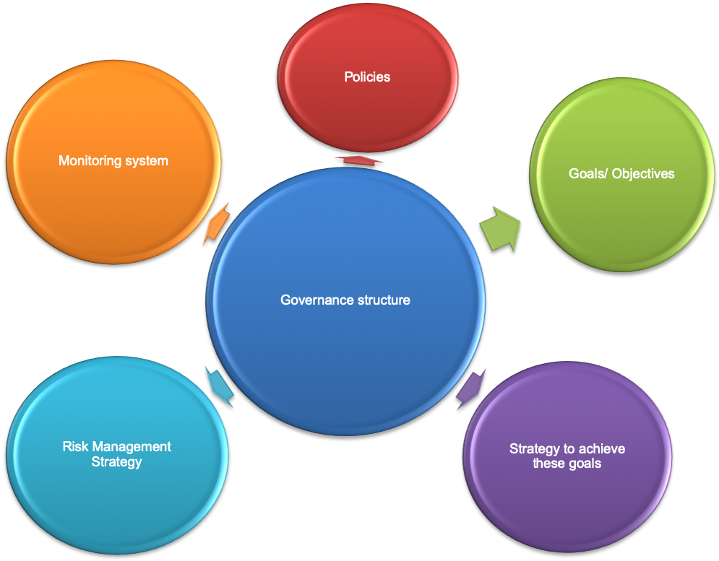

8.1 What does Fund Governance entail?
Retirement fund governance is a subset of Corporate Governance. The same governance principles that apply in the corporates should apply in managing pension assets.
The governance of funds involves the managerial control of the organizations and how they are regulated, including the accountability of service providers and how they are supervised.
The four pillars below should form the basis of the governance structure and mechanisms;
  Organizational Coherence
  •Clarity of purpose
  •Structure of the governing board
  •Proper allocation & deployment of resources
  People
  •Qualities
  •Skills
  •Competencies
  •Recruitment
  •Remuneration Practices
  •Protection
  Processes
  •General decision-making processes
  •Investment decision-making
  Accountability Mechanisms
  •Whistle-blowing
  •Service-provider mandates & agreements

The basic goal of Retirement Fund governance is to minimize the potential agency problems, or conflicts of interest, that can arise between the fund members and those responsible for the fund’s management, and which can adversely affect the security of retirement savings and promises.
Good governance also goes a long way in achieving the following;
- delivering high Retirement Fund performance while keeping costs low for all stakeholders
- creating trust amongst all stakeholders,
- reducing the need for prescriptive regulation, and facilitating supervision
- positive collateral effects on economy-wide efficiency, strengthening the fund’s role as effective shareholders
- Enhancing investment performance and benefit security.
- Ensures trustees act in the best interests of the fund and its members.
Purposes of Good Fund Governance are to ensure that;
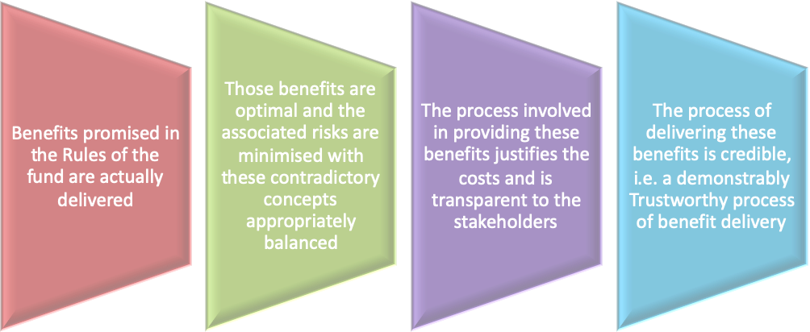

Fund Governance principles are based on three broad areas
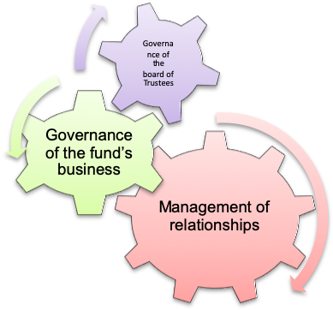

8.2 Tools that Trustees use to enhance Governance
Fund Procurement Policy
Communication Policy
Trustee Training Policy
Investment Policy Statement
Risk Management Policy
Expense Management Policy
Conflict of Interest Declaration Policy
Trustee Code of Conduct
Fund Governance Tools

8.3 King IV Code – Aspects relevant to Retirement Fund Governance
The King IV Report on Corporate Governance for South Africa (“King IV”) became effective from 1 April 2017. King IV sets out recommendations and guidelines for the governance in South Africa but has been adopted by many other countries worldwide.
King IV reduces the 75 principles set out in King III, to 17. Entities are required to exercise the “apply and explain” principle, unlike the King III code which made provision for an “apply or explain” principle.
King IV provides a supplement focusing entirely on the retirement funds amongst other sectors given the prominent role that retirement funds play in the institutional investor industry and the economy as a whole.
Retirement funds are crucial in the entire governance structure in the economy principally for two reasons;
- When making investment decisions
- As shareholders in the majority of companies on the stock market.
How investment decisions and shareholder decisions are made have huge implications on how the governance structures and direction of the whole economy goes. Principles like BBBEE could, therefore, be effectively implemented by pension funds and impact the economy as a whole.
Trustees have a fiduciary duty to their members to ensure that investments and the companies in which they invest are well well-governed, and the principles of responsible investing applied to ensure positive and sustainable returns.
Retirement funds can effectively transform the narrative in the governance of both pension funds and other organisations by implementing an oversight role in the entire economy to ensure that the long-term interests of their members and the communities they represent are protected and advanced.
A summary of the principles is as follows:
Principle 1 | The Board of Trustees should lead ethically and effectively.
Principle 2 | The Board of Trustees should govern the ethics of the fund in a way that supports the establishment of an ethical culture.
Principle 3 | The Board of Trustees should ensure that the fund is and is seen to be a responsible corporate citizen.
Principle 4 | The Board of Trustees should appreciate that the fund’s core purpose, its risks and opportunities, strategy, business model, performance, and sustainable development, are all inseparable elements of the value creation process.
Principle 5 | The Board of Trustees should ensure that reports issued by the fund enable stakeholders to make informed assessments of the fund’s performance and its short, medium, and long-term prospects.
Principle 6 | The Board of Trustees board should serve as the focal point and custodian of corporate governance in the fund.
Principle 7 | The Board of Trustees should comprise the appropriate balance of knowledge, skills, experience, diversity, and independence for it to execute its governance role and responsibilities objectively and effectively.
Principle 8 | The Board of Trustees should ensure that its arrangements for delegation within its structures, promote independent judgment and assist with balance of power and the effective execution of its duties.
Principle 9 | The Board of Trustees should ensure that the evaluation of its performance and that of its committees, its chair, and its members, support continued improvement in its performance and effectiveness.
Principle 10 | The Board of Trustees should ensure that the appointment of and delegations to management contribute to role clarity and the effective exercise of authority and responsibilities.
Principle 11 | The Board of Trustees should govern risk in a way that supports the fund in setting and achieving its strategic objectives.
Principle 12 | The Board of Trustees should govern technology and information in a way that supports the fund setting and achieving its strategic objectives.
Principle 13 | The Board of Trustees should govern compliance with applicable laws and adopted, non-binding rules, codes, and standards in a way that supports the fund being an ethical and responsible corporate citizen.
Principle 14 | The Board of Trustees should ensure that the fund remunerates fairly, responsibly and transparently, to promote the achievement of strategic objectives and positive outcomes in the short, medium, and long term.
Principle 15 | The Board of Trustees should ensure that assurance fosters an effective control environment, therefore supporting the integrity of information for internal decision-making and of the fund’s external reports.
Principle 16 | In the execution of its governance role and responsibilities, the Board of Trustees should adopt a stakeholder-inclusive approach that balances the needs, interests, and expectations of material stakeholders in the best interests of the fund.
Principle 17 | The Board of Trustees should ensure that responsible investment is practiced by the fund to promote good governance and the creation of value by the companies in which it invests.
Key issues from the King IV report;
- Move away from box-ticking to “mindful application” – understand why we do what we do.
- Value addition - Implementation to achieve results, not just compliance.
- Explaining how it is applicable in the direct scenarios taking into account the different organizations.

8.4 Governance Principles that the board should observe are;
The South African Financial Services Board (now FSCA) has come up with the following Fund governance principles that have been acclaimed worldwide as the pinnacle for good fund governance.
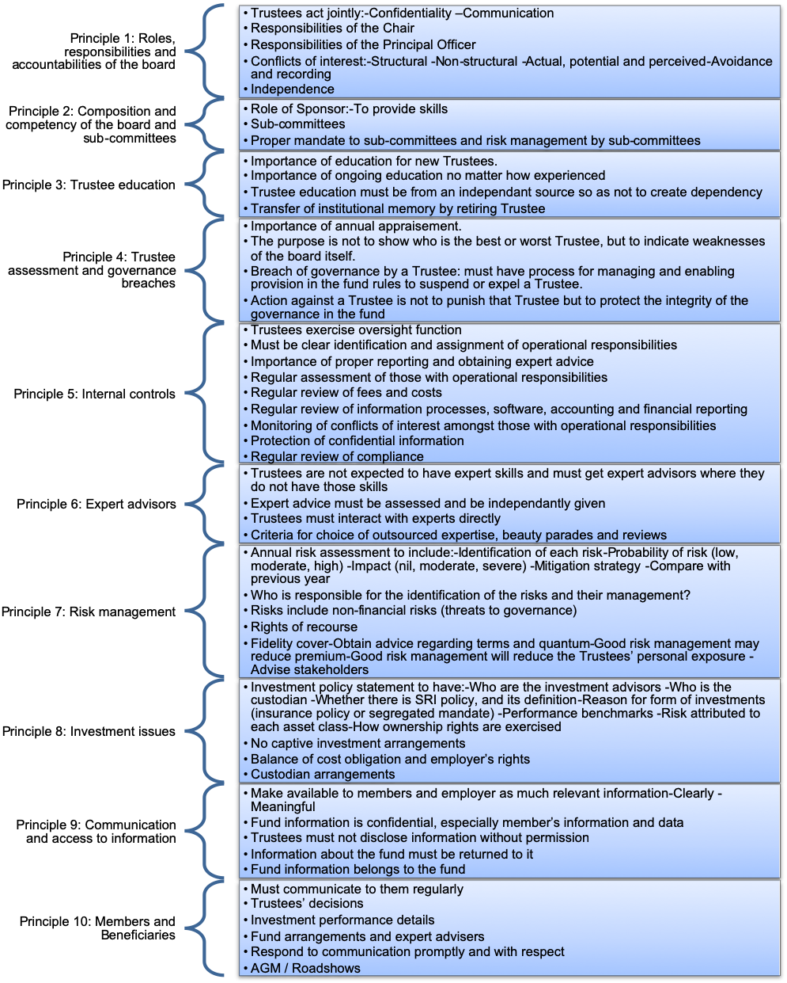

Chapter 9

Industry Role Players
Good knowledge of this chapter will ensure competency in the following specific outcomes:

- Explain the function played by the different role players in the industry

9.1 The Member / Beneficiaries
The member is the central part of all these arrangements. It is therefore imperative that the focus should be on ensuring that the member is empowered to understand the benefits and make the necessary decisions. There is no point in entering all these complex arrangements but leaving out the critical component.
The fund's communication policy should, therefore, be strengthened to empower the member and beneficiaries to make the right decisions along the way so that the overall objectives of the fund are met.
Trustees should consider seriously engaging the members on an ongoing basis.

9.2 The Board of Trustees
The Board of Trustees is the ultimate decision-maker, having overall responsibility for strategic decisions such as setting the investment policy, choosing the investment manager(s) and other service providers, and reviewing the fund’s performance. The Board of Trustees is the equivalent of the board of directors of a company, which has the ultimate responsibility for protecting the shareholders’ assets.
The central role played by the Board of Trustees is ensuring good governance and raising value for all stakeholders. The success of the fund is therefore directly linked with the quality of the Board in charge of the affairs of the fund.
The roles and responsibilities of the Board of Trustees are covered fully covered in Chapter 2.
It is, however, imperative that as the driver of the fund, the Board of Trustees is at all times fully constituted and has the necessary skill set to enable efficient and effective decision making.
The Board of Trustees is also responsible for the appointment of all the other role players that manage the fund. The Board should, therefore, be fully accountable for its decisions and ensure that all decisions are done in the best interest of the fund members.
As the custodians of the fund’s assets, the Board of Trustees must ensure that governance mechanisms are put in place to ensure that fund assets are safe and grow at optimum levels whilst managing the risk exposure.
Being a Trustee is an onerous task that should be taken seriously.

9.3 The Principal Officer (Section 8, Pension Funds Act).
In terms of the Pension Funds Act, every fund must have a Principal Officer.
The board of a fund is responsible for the appointment of a principal officer and must ensure that the appointee:-
- has the relevant qualifications and expertise relating to the management and oversight of retirement funds, specifically to the particular office and type of fund in question;
- is fit and proper to hold such appointment; and
- Has been informed of his/her duties and responsibilities in terms of the applicable legislation.
Once the board of a fund is satisfied that an appointee meets all the above minimum criteria, the board must notify the Registrar of the appointment by completing the appropriate forms.
The Principal Officer, being an appointed officer of the fund in the same way as the Trustees, and being a person in a position of Trust, has very similar fiduciary duties.
The principal officer of a registered fund shall be an individual who is a resident in the Republic.
A registered fund may appoint a deputy principal officer.
If a fund has appointed a deputy principal officer, the deputy principal officer acts as a principal officer when the principal officer is absent from the Republic or unable for any reason to discharge any duty of the principal officer.
Because the Principal Officer must sign certain fund documents in his capacity as Principal Officer, he/she may not be appointed as chairperson of the Board of Trustees. However, the Principal Officer is not precluded from acting as an ordinary member-elected or employer-appointed Trustee.
The Principal Officer's duties and functions, other than those specifically provided in the Act, are determined by the fund rules to a large degree.
The Principal Officer can be likened to a company secretary in many respects and is usually an authorized signatory. All general fiduciary duties applicable to Trustees apply equally to the Principal Officer. The Principal Officer plays a pivotal role in the fund. For this reason, the Principal Officer must have a very thorough knowledge of the fund and its administration, as well as of the Act, its regulations, and any other applicable legislation.

9.4 Chairperson of the Board of Trustees
The Rules specify who chairs the meeting or may simply provide that the Trustees shall decide at each meeting who will carry out that role. The following are the key roles of the chairperson;
- Proactively lead the Board impartially and without bias to any party;
- Confirm the agenda for board meetings and review draft minutes of such meetings;
- Ensure that the business stated on the agenda is completed.
- Manage board meetings to ensure that sufficient time is allowed for discussion of complex or contentious issues;
- Ensure formal and regular performance reviews of the board as a whole, the subcommittees and the principal officer are conducted;
- Meet regularly with the Principal Officer to monitor the operations of the Fund;
- Act as the spokesperson of the Fund; and
- Proactively raise issues of concern, on behalf of the board, the sponsor, the employer, the administrator, and other service providers.
- If the rules provide for majority voting, the chairperson will usually be given a casting vote if the votes are tied.

9.5 The Investment / Asset Manager
The Investment Manager must ensure that the assets are managed according to the mandate agreements, taking into account all legal requirements; record-keeping, international best practice, and that Trustee receive regular reports.
The most important duty of the investment manager is to ensure that the Fund’s assets are invested in such a way that optimum returns subject to acceptable risk are achieved. This means that the investment manager in conjunction with the Board of Trustees must seek the investment portfolio which offers a high return while keeping risk factors within acceptable limits, and which keeps the fund suitably liquid so that it has money readily available to pay benefits as and when required.
In determining the type of investments in which to invest the fund's assets, the investment manager must have regard to:
- The fund’s objectives
- The need for diversification
- The need for cashflow
- The membership and demographic profile of the fund
- The size of the fund.
The investment manager has a responsibility to understand the fund's objectives and to provide asset management which he believes will satisfy those objectives in the form of an optimum return.
Before an investment is made in a particular area, industry, or asset, the investment manager must properly research the historical record of returns that the potential investment has offered and analyse the particular investment's strengths and weaknesses, opportunities, and threats. He must also be familiar with the local and global economic climates and take cognizance of factors that may influence them.
The Investment Manager must have the necessary personnel and systems in place to assist with the necessary research and valuation techniques to offer value to the fund.

9.6 Investment Consultant
- Provide independent and objective advice to the Trustees;
- Advise Trustees on a suitable investment policy;
- Recommend to Trustees on a suitable investment strategy;
- Assist Trustees in choosing and appointing investment managers;
- Monitor Fund compliance with investment regulations;
- Review investment mandates and agreements;
- Monitor the Fund’s investment results relative to benchmark and peers at portfolio
and Fund level;
- Advise trustees with investment matters generally; and
- Keep trustees abreast of market developments.

9.7 The Fund Valuator / Actuary (Section 9A of the Act)
Every retirement fund shall appoint an actuary as a valuator provided that such appointment shall be considered provisional and be of no force until the Registrar has approved the appointment in writing.
The appointed valuator is responsible for valuing the fund's liabilities and the fund's assets for actuarial purposes according to generally accepted actuarial practice and producing a report thereon.
The appointed valuator should bring to the Registrar's notice any practice or irregularity which he considers might harm the members' interest and also on the termination of his appointment by the retirement fund bring to the Registrar's attention any irregularity that he is aware of which might prejudice the members of the fund.
The Valuator's primary duty to evaluate the financial soundness of the fund by valuing assets and liabilities and recommend to the Fund on:
- The contributions required to fund benefits.
- The financial soundness of benefits.
- The interests of particular members in the fund, where these could apply to one member or extend to all members, as in the case of a take-over or merger.
- The rate at which the fund commutes pension benefits for cash.
- The increases that can be granted to pensioners.
- The amount of past service that can be recognized in the fund in return for the benefits brought into the fund (usually from a previous fund) by new members.
- Bonus declaration for Defined Contribution funds.
- Conversion valuation
- Asset Liability matching
- Reserve calculations for Defined Benefit Funds.
Role of Actuaries in Defined Contribution Funds
Admittedly there are few purely technical issues in DC Funds, the members who face the risk, need quality advice.
The possible areas for Actuary involvement are:
- Fund design by considering alternative designs for different objectives. The effect of future conditions on these benefits can be assessed to assess the risk.
- Targeting one benefit has implications for benefits arising in other situations.
- The impact on the future cash flow for the employer and linkages to recruitment, staff turnover, and salary progression.
- Statutory valuation.
- Review of the continued ability of the Fund to meet its original objectives.
- Illustrations of benefits
- Investment selection and risk management.
- Design of investment vehicles.
- Annual interest declarations.
As the risks are transferred to the employee, there is a greater need for advice for the members and the Trustees.
Other duties are;
- Prepare and present to the Trustees the Annual Financial Review of the Fund;
- Provide professional actuarial advice to the Trustee on any issues that may adversely affect the solvency and/or financial position of the Fund;
- Provide professional actuarial advice to the Trustees on transfer issues, including the signing of relevant legal documents about transfers;
- Provide professional actuarial advice and assistance with the strategic asset allocation and the investment strategy, considering the Fund’s liabilities, expenses and projected benefit obligations as set out by the Fund; and
- Provide signed documentation that the Fund’s investment policy and investment strategy are appropriate and consistent with the objectives of the Fund.

9.8 The Fund Auditor
Section 9 of the Act deals with the issue of fund audits as follows;
- Every retirement fund shall appoint an auditor for its business provided that such appointment shall be considered provisional and be of no force until the Registrar has approved the appointment in writing.
- An application for approval of the appointment of the auditor shall be made in terms of the Act within 30 days from the date of the provisional appointment of the auditor.
It is the auditor's fiduciary duty to ensure that the necessary books of account, annual financial statements, and auditor's report, many of which must be submitted to the Registrar each year, are drafted following appropriate, generally accepted accounting practice and comply with the Act.
The annual financial statements should fairly represent the financial state of affairs of the fund.
Ideally, the auditor should meet with the Trustees before the commencement of an audit to discuss and review the audit objective and procedures to ensure that all areas are properly dealt with.
This report must contain an expression of opinion on the financial soundness of the fund.
The auditor must also ensure that the fund's investments, administration and turn-around times are following the rules of the fund and the agreed service levels.
Where an Insurer is the fund administrator, the auditor must be satisfied and certify that the Insurer's accounting systems and controls are adequate for retirement fund administration and that such administration is carried out in compliance with the provisions of the Act.
The systems and controls must be able to determine whether or not contributions to the fund have been made timeously in terms of the Act.
An auditor of a fund must -
- within 21 days of his or her appointment is terminated, other than following section 8 submit a written report to the registrar detailing the auditor's perceived reasons for the termination;
- if the auditor, but for the termination referred to in paragraph (a), would have had reason to submit a report contemplated in section 45 (3) of the Auditing Profession Act 2005, (Act No. 26 of 2005), submit such a report to the registrar; and
- On becoming aware of any matter relating to the affairs of the pension fund, which, in the opinion of the auditor, may prejudice the fund or its members, inform the registrar thereof in writing.

9.9 The Employer
The employer plays a critical role in the running of the fund. Certain fiduciary duties arise because the employer has, by establishing a fund, agreed with his employees to help provide for their retirement, and because the money contributed to the fund, both by the employer and the employee, constitutes Trust money.
For these reasons, the most important fiduciary duty owed by the employer to the fund is the duty to act with the utmost good faith, care, and diligence when dealing with the affairs of the fund and to exercise his authority fairly and reasonably. The employer must be valid in his desire to establish a fund.
A fund established as a tax evasion fund and designed to enrich the owner of the business/employer, besides being illegal, would be a very serious breach of fiduciary duty, with serious industrial relations consequences when uncovered.
The employer is thus expected to exercise this fiduciary duty, amongst others, when:
- Designing benefit structures and setting up the fund in consultation with the Trustees.
- Appointing the employer Trustees.
- Making / deducting and submitting contributions to the Fund.
- Ensuring that all eligible employees join the fund.
- Ensuring that members are not allowed to leave the fund or receive benefits from it unless they are genuinely leaving his service.
- The employer must co-operate fully with the Trustees and administrators of the fund. This especially applies with regards to furnishing details of salary increases, change in status (marriages, additions or subtraction to family), and staff turnover. This kind of information must be supplied as soon as any changes occur.
- There is also a duty on the employer to ensure that the fund is being properly managed.
- Any unreasonable restraint of the Trustees' discretion or interference with the Trustees in the performance of their duties by the employer is unacceptable. The Trustees have been placed in the position to do a particular, often onerous job, and they should be left to do it as they see fit. The employer must monitor the work done by the Trustees and their performance, and intervene where such performance is not up to standard, but this is very different from unreasonable and unnecessary interference.
- The employer must be particularly careful not to place, or be seen to place, pressure on fund Trustees, especially those who are also his employees, concerning any decisions regarding the fund. It would be a gross abuse of power and fiduciary duty for an employer to use his powers (as the employer) to coerce fund Trustees in any way.
- The employer is often placed in a difficult position because there is always going to be a conflict between providing meaningful benefits and the cost of doing so.
However, the employer must always keep in mind that he stands in a fiduciary relationship to the fund and that he must provide his staff with meaningful benefits if he can afford them. Once the employer recognizes that the fund is a separate entity, not simply another business asset and that contributions by the employer to the fund are part of a member's remuneration, the conflict of interest that does exist will lessen considerably.

9.10 The Fund Administrator
Fund Administrators are required to be registered before they undertake the administration of retirement funds.
The fund administrator is responsible for the efficient running and administration of the fund. It is the pivotal link between the Member, the Employer, the Trustees, and the Insurer, Investment Manager, Valuator, Auditor, and so on. The provision of this continuity between these various persons is more than merely a fiduciary duty. It is integral to the very performance of the administrator's function. Should any of the various persons responsible for the fund not be performing properly, the administrator has to either correct the situation or seek assistance in doing so.
The administrator must ensure that:
- All eligible employees are in fact members of the fund.
- In terms of the Act, it monitors the payment of the contributions by the employer to the administrator. The payment must occur within the stipulated time. If the employer does not pay the contributions within this period, the administrator must inform the fund's Principal Officer of the non-payment, who in turn should advise the Registrar.
- The necessary documentation regarding the admission of new members is obtained from members/employers and advised to the Insurer or investment manager where applicable.
- Documentation regarding the cessation of membership is obtained from members/employers and advised to the Insurer or investment manager where applicable.
- An adequate record of member and employer participation in the fund is maintained to enable the accurate determination of any benefits accruing to a member.
- The timeous payment of benefits due to members or other interested parties on cessation of participation, and that it obtains the necessary resources from the Insurer or investment manager for this purpose.
- Compliance with the fund rules, with any statutes and regulations affecting the operation of the fund, and with any contracts and policies which the fund is a party to.
- Timeous referral of any matter requiring the attention of any other officer of the fund. In particular, the administrator should make regular and detailed reports to the Trustees on all material matters, such as the membership profile, member movements, benefit payments made and contributions received.

9.11 The Benefit Consultant
The consultant is an important link between the various officers and members of the fund, the Insurer if any, and the employer. As such, he often serves a vital role in advising the employer and where necessary, the Trustees, on numerous aspects regarding retirement funds. Such aspects would include:
- Discussing matters such as the financial operations of the fund, investments and the impact which factors like HIV / AIDS could have on the fund in general.
- Discussing and advising on the structure of benefits, how current benefits compare with other alternatives, new products, and market trends, and suggesting suitable amendments to the fund rules where applicable.
- Advice on insurance policies and insurance matters. A consultant would be guilty of negligence if he failed to advise the Trustees on insurance policy conditions, limitations, and exclusions.
- Advice on relevant changes in legislation and how these will affect the operation of the fund.
- Advice on possible industrial relations consequences of rule amendments or discriminatory practices currently entrenched in the rules which could subsequently be challenged on constitutional grounds.
- Ensure that the benefit and fund design is precisely what the employer, Board of Trustees, and members seek to achieve by establishing the fund.
- The consultant also serves a vital role in advising the employer, Board of Trustees, and the fund members on issues regarding retirements, withdrawals, taxation principles, the continued compliance with the rules of the fund by the Trustees, administrator, and so on.
Generally, every consultant has a fiduciary duty to perform the mandate given to him by his client as expeditiously as possible and always to act in the client's best interests.
In some respects, the consultant also has to act as a watchdog, chasing up the various officers of the fund and ensuring that they are all doing their duties efficiently and timeously. To this end, the consultant, in conjunction with the Trustees, should initiate and attend regular meetings of the various officers of the fund. How often these meetings are held will depend on circumstances such as the make-up of the fund, its investment portfolio, member profiles, and so on, all of which can change. Meetings must, therefore, be held as frequently as is a necessary subject to a minimum as stipulated by legislation.

9.12 Life Assurance Company
Virtually all Retirement Funds provide a benefit or benefits payable on the death or disability of a member whilst in the service of the employer. The Trustees of a small/medium size fund will generally fully insure this benefit with a life assurance company so that in the event of the death or disability of a member the Trustees will receive from the life assurance company a payment which precisely matches their liability. On the other hand, a larger Retirement Fund may insure none, or only a part, of the death benefit and instead pay the full/remaining part of the death benefit from the assets of the fund.

9.13 The Financial Sector Conduct Authority (FSCA) and Prudential Authority (PA)
The FSCA's mandate is to enhance the efficiency and integrity of financial markets; promote fair customer treatment by financial institutions; provide financial education and promote financial literacy; and assist in maintaining financial stability.
The Prudential Authority (PA) is the regulator responsible for setting policy and prudential regulatory requirements and supervisor responsible for overseeing compliance with the regulatory requirements of financial institutions that provide financial products, securities services, and market infrastructures.
The Financial Sector Conduct Authority (FSCA) is responsible for market conduct regulation and supervision. FSCA aims to enhance and support the efficiency and integrity of financial markets and to protect financial customers by promoting their fair treatment by financial institutions, as well as providing financial customers with financial education. The FSCA will further assist in maintaining financial stability.

9.14 The Office of the Pension Funds Adjudicator
The office of the Pension Funds Adjudicator is a statutory body established in terms of section 30B of the Pension Funds Act, 24 of 1956. Section 30B entrusts the responsibility of carrying out the mandate on the Pension Funds Adjudicator and the Deputy Adjudicator/s. The Adjudicator and/or the deputy Adjudicators are appointed by the minister of Finance in consultation with the FSCA.
The mission of the OPFA is to resolve complaints in terms of the Act to uphold the integrity of the pension fund industry and to protect the interests of pension fund members.
The mandate is to resolve Financial Services complaints in a procedurally fair, economical, and expeditious manner.

A complainant would be any person who is, or who claims to be —
- a member or former member of a fund;
- a beneficiary or former beneficiary of a fund;
- an employer who participates in a fund;
- a spouse or a former spouse of a member or former member, of a fund;
- any group of persons referred to in paragraph (i), (ii), (iii) or (iv) above;
- a board of a fund or member thereof; or
- any person who has an interest in a complaint;
A complaint means a complaint of a complainant relating to the administration of a fund, the investment of its funds or the interpretation and application of its rules, and alleging—
- that a decision of the fund or any person purportedly taken in terms of the rules was more than the powers of that fund or an improper exercise of its powers;
- that the complainant has sustained or may sustain prejudice in consequence of the maladministration of the fund by the or any person, whether by act or omission;
- that a dispute of fact or law has arisen concerning a fund between the fund or any person and the complainant; or
- That an employer who participates in a fund has not fulfilled its duties in terms of the rules of the fund.

9.15 South African Revenue Service
SARS is responsible for the collection and administration of all national taxes, duties, and levies. SARS administers the tax affairs relating to deduction of retirement fund contributions and calculation of tax payable when benefits become due and payable to the member or beneficiary.
9.16 South African Banks – facilitate payment of contributions and benefits.

Glossary of Pension Terms
The following is a list of the more common technical terms, which the Trustee is likely to encounter in practice.
Accrual Rate
The rate at which a pension benefit is earned in a Defined Benefit fund, e.g. 1/60th of Final Pensionable Salary for each year of service.
Accrued Benefits
The benefits earned in respect of service up to a particular point in time, whether vested or non- vesting. These benefits may be calculated concerning current earnings or projected earnings and allowance might be made for increases provided for by the fund rules or by legislation.
Active Member
A member of a Pension Fund who is in “quantifiable service‟, i.e. currently in the employment to which the fund relates, and who is included in the fund for a pension benefit.
Actuarial Assumptions
In a Defined Benefit fund the set of assumptions made by the actuary as to rates of investment return, inflation, increase in earnings, mortality, etc. which form the basis of an actuarial valuation or other actuarial calculation
Actuarial Valuation
An investigation by the Actuary into the ability of a Defined Benefit Pension Fund to meet its benefit payment obligations as per the rules of the fund. This has two purposes, 1) the actuary will calculate a recommended contribution rate, which will allow the fund to meet its future liabilities. 2)the actuary will establish the ability of the existing assets of the fund to meet its accrued benefits and complete an actuarial funding certificate.
Actuary
An adviser on financial matters involving the probabilities relating to mortality and other contingencies affecting Pension Fund financing.
Additional Voluntary Contributions (AVCs)
Contributions, which a member elects to pay over and above his/her normal contributions to secure additional pension benefits.
Annual Report
The Act requires the Trustees of a retirement fund to communicate information about the fund, its administration, and its financial position regularly.
Annuity
A series of payments made at stated intervals until a particular event – usually the death of the person receiving the annuity – occurs. It is normally secured by the payment of a single premium to an insurance company.
Beneficiary
A person entitled to benefits under a Retirement Fund or Group Life Assurance Fund will become entitled to the happening of a specified event (e.g. on the death of a member).
Benefit Statement
A statement of the benefits payable in respect of an individual on the occurrence of specified events such as death, retirement, or withdrawal. These values are usually given at the fund’s year-end or any other time as agreed by the parties.
Commutation
The exchange of pension in a Defined Benefit fund for an immediate cash lump sum within Revenue limits
Continuation Option
A facility offered by an insurance company, which ensures funds death benefits, whereby a member who is leaving the fund, can take out a personal life assurance policy without having to provide evidence of health.
Contribution Holiday
A term used to describe a period under which an employer and/or member’s contributions are suspended. This usually happens when a Defined Benefit fund is an insignificant surplus.
Contributory Fund
A Retirement Fund, which requires contributions from active members.
Custodian
A person or body responsible for holding the assets of a Trust in safe custody.
Deferred Annuity
An annuity, which commences from a future date.
Deferred Benefit
Any benefit payment which is deferred, e.g. until a person reaches normal pensionable age. Most often used to refer to benefits, which accrue to a fund member on leaving service.
Deferred Member
A person entitled to a pension payment at a future date. Normally this would be an early leaver but the term is sometimes used to describe someone whose retirement is being postponed.
Deficit
In a Defined Benefit fund, any excess of the value of a fund’s liabilities over the value of its assets as calculated by the actuary of the fund. Also referred to as shortfall.
Defined Benefit Fund
A fund where the pension and other benefits that will be paid to the member and/or the members’ dependants are clearly stated in the Rules of the Fund. Where the benefits are based on a future salary, e.g. at retirement, it is known as a Final Salary Fund. Where the benefits are based on a member's salary in the year in which the benefit is earned, it is known as a Career Average Fund.
Defined Contribution Fund
Also known as a Money Purchase Fund – a fund where the rate of contribution (employer and, if contributory, member) is defined and where the individual member’s pension is determined solely by reference to the contributions paid into the fund by or on behalf of that member and the investment return earned on those contributions.
Dependant
A person who is financially dependent on a member or pensioner or was so at the time of death or retirement of the member or pensioner. For revenue purposes, a child of the member or pensioner may always be regarded as dependant until he or she reaches the age of eighteen or ceases to receive full-time education.
Disability Benefit
A benefit is payable to a member, who is unable to work for medical reasons. This may be paid from a Pension Fund as an ill-health early retirement benefit or it may be payable by the employer either directly or under the terms of an insurance policy or income continuance plan (which are not part of the Pension Fund). A disability benefit can also arise under a voluntary disability insurance fund, paid for in full by its members.
Early Retirement
The retirement of a member, with immediate retirement benefit, before normal pensionable age. Under a Defined Benefit Fund, the benefit may be reduced because of early payment.
Eligibility
The conditions which must be met for a person to be a member of a fund or to receive a particular benefit. These may for example relate to age, service, status, and type of employment.
Employer
The person or body with whom the member of a Pension Fund has a contract of employment relevant to that fund.
Escalation
A system whereby pensions in payment and/or preserved benefits are increased regularly at a fixed or variable percentage rate. The percentage increase applied may be limited to the increase in a specified index. Escalation may be promised and paid for in advance or may be granted on a discretionary basis after the pension has commenced.
Ex-gratia Benefit
A benefit provided by the employer / Trustees or Insurer that they are not legally required to provide. The member cannot enforce payment of such a benefit.
Final Pensionable Earnings/Final Pensionable Salary
The pensionable earnings, at or near retirement or leaving service, on which the pension is calculated. This may be fixed at a particular date or may be based on an average of several years.
Free Cover Limit
The maximum amount of death benefit that an insurance company covering a group of members for death benefits is prepared to ensure for each individual, without requiring evidence of health.
Funding
The provision in advance for future benefit liabilities by setting aside money in a Trust, which is separate from the employer’s business, to finance the payment of benefits when they arise.
Funding Rate
The rate at which contributions are payable to support the liability for benefits. Often used as shorthand for Recommended Contribution Rate.
Funding Standard
This is designed to ensure that, at a minimum, the fund has sufficient funds to secure specified pension rights which members have built up if the fund should have to be wound up at any stage. Funds are usually wound up when the employer company goes out of business.
Guaranteed Payment Period
A period, normally between five and ten years, for which payment of a pension would be guaranteed by the fund rules, whether the pensioner lives or dies.
Ill-health Early Retirement
Retirement on medical grounds before normal pensionable age. Under a Defined Benefit Fund, the benefit payable in these circumstances may be greater than that paid to a member retiring early in normal health.
Immediate Annuity
An annuity which commences immediately or shortly after its purchase.
Insured Fund
A Pension Fund where the sole long-term administration and investment arrangement used by the Trustees is an insurance policy. An insurance company with whom the Trustees have taken out a contract to pay regular premiums provides all of the benefits.
Investment Manager
A person or body to which the investment of the whole or part of the assets is delegated by the Trustees following the provisions of the Rules of the Fund.
Investment Performance Measurement
The comparison of the rate of return of a given Retirement Fund with the notional return of a hypothetical fund, or the actual rates of return of other funds, over the same period.
Late Retirement
The retirement of a member, with immediate retirement benefits, after normal retirement age. The benefit may be increased because of later payment.
Liabilities
Amounts due to be paid by a Retirement Fund now or in the future as a result of obligations it has undertaken. The amounts may not be immediately ascertainable and some liabilities may be contingent on the happening of future events.
Life Assurance Fund
A fund that provides only a benefit payable on death or disability whilst in service.
Management Committee
These terms tend to be used in a variety of senses. A Management Committee may provide a local forum for active members especially in a large Retirement Fund where the active members are spread over a large number of sites. As such it serves as a pension’s consultative committee. Similarly, some employers will negotiate with trade unions and employee representatives on pensions. This may be through the usual negotiation machinery or special pension negotiation committees and the term Management Committee might be used in this context. The term also used under Umbrella funds.
Managed Fund
An investment contract under which an insurance company or other institution offers participation in one or more investment funds consisting of a collection of pooled assets from several Funds.
Member
A person who has been admitted to membership of a Retirement Fund and who is entitled to benefits under the fund. This will include active members, deferred members, and pensioners.
Member Trustees
Trustees who are elected by members or whose appointment by the employer has been approved by the fund members following the regulations made under the Act.
Nomination Form
A form used by a member to nominate a person or persons to whom he or she wishes any death benefit to be paid to in the event of his/her death. This acts as a guide to the Trustees.
Non-contributory Fund
A Pension Fund that does not require contributions from active members, i.e. the employer is liable for all contributions needed to support the fund.
Normal Retirement Age
The age by reference to which the normal retirement date is determined.
Normal Retirement Date
The date on which a member of a Retirement Fund normally becomes entitled to receive retirement benefits. This date is the benchmark, which determines early retirement and late retirement.
Occupational Retirement Fund
The term is generally used to distinguish job-related Retirement Funds from State Social Welfare funds.
Paid-up Benefit
A benefit secured for an individual member based on past membership but has now ceased to contribute to the Fund and insurance whose premiums have ceased to be payable in respect of that member.
Past Service Benefit
The benefit granted in respect of past service.
Pension Fund
An arrangement, other than accident insurance, to provide pension and/or other benefits for members on leaving service or retirement and for the member’s dependents in the event of the death of the member.
Pensionable Earnings
The earnings/salary on which benefits and/or contributions are calculated.
Pensionable Service
The period of service, that is taken into account in calculating the pension benefit.
Pensioner
A person who is currently receiving payment of a pension from a Fund.
Preserved Benefits
This term is often used to describe any benefit emerging on termination of employment or of membership of a Retirement Fund, which is payable at a later date.
Registered Administrator
A registered administrator is a person who is registered to provide specified core administration functions for Trustees.

Rules
The detailed provisions of a Retirement Fund normally set out formally and usually given authority by the Act and subordinate legislation.
Self-Administered Fund
A Retirement Fund where the assets are held in the name of the fund and not through a policy of insurance.
Statement of Investment Policy Principles (SIPP)
All funds except small funds must prepare a Statement of Investment Policy Principles (SIPP). The SIPP requirements do not impose any specific investment practices on Retirement Funds; the SIPP is intended to be a description of the investment policies of the Trustees.
Surplus
In a Defined Benefit fund, any excess of the value of a fund’s assets over the value of its liabilities as calculated by the actuary of the fund.
Transfer Payment
A payment from one Retirement Fund to another fund, instead of the benefits, which have accrued to the member under the previous fund.
Vested Rights
This has different meanings for different people.
(a) For active members, benefits to which they would unconditionally be entitled to leaving service, which may or may not include statutory rights to preserved benefit
(b) For deferred pensioners who have already left the employment, they are deferred/preserved benefit.
(c) For pensioners, the pension, which they are receiving, including, where appropriate, the related benefits for spouses and other beneficiaries.

References
- OECD-IOPS Mena Workshop on Pension Regulation and Supervision 6 2/3 February 2009; Fiona Stewart, Administrator; OECD Financial Affairs Division
- OECD Working Papers on Insurance and Private Pensions No- 18: “Pension Fund Governance: Challenges and Potential Solutions”. 2008
- Deloitte: Corporate Governance (King III) - in the Retirement Funds environment; November 2010
- Institute of Directors Southern Africa
- Nkonki Inc: Getting to grips with King IV 2016
- Financial Service Board: Role of Trustees
- Liberty Corporate: The Fiduciary Duties of Retirement Fund Trustees
- ‘Fit and Proper’ Requirements and Trustee Liability Issues; Tashia Jithoo
- Momentum Legal Updates
- HotTopics – Alexander Forbes updates
- EBNet articles
- The Pension Funds Act, 1956
- Financial Sector Regulation Act
- The Default Regulations

